PRELIMINARY DRAFT ADSN-ARDC Survey Stage 2 Analysis
PRELIMINARY Deliverables 3.1 and 4.1
Alberto Nettel-Aguirre
09 April, 2026

Preliminaries
The results presented here are based on 89 respondents.
The data had 99 responses, of which 98 consented, and of which, 89 took at least one minute to complete it.

Which of the following best describes your primary research area?
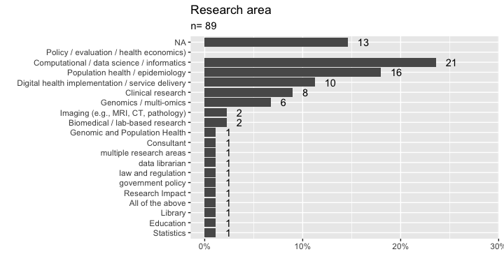

What is your current career stage?
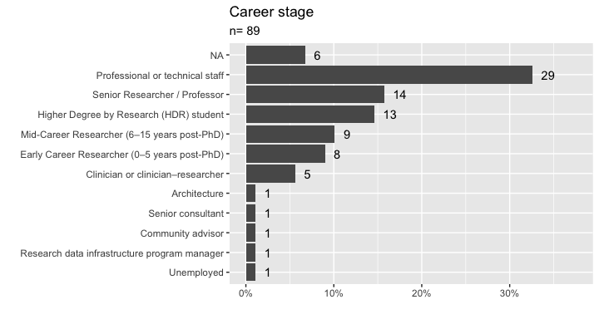

What is your current primary position?
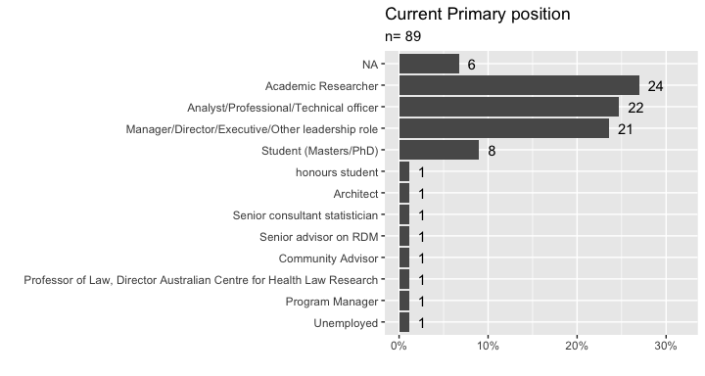

Rate your analytics and/or programming skills below

Applied statistics/mathematics
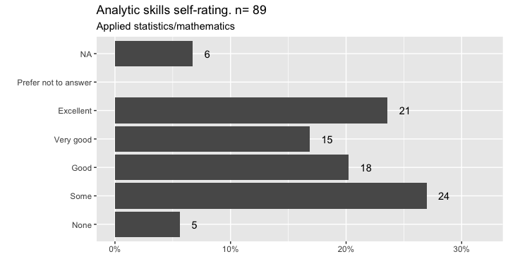

Artificial Intelligence (AI) and Machine Learning (ML)
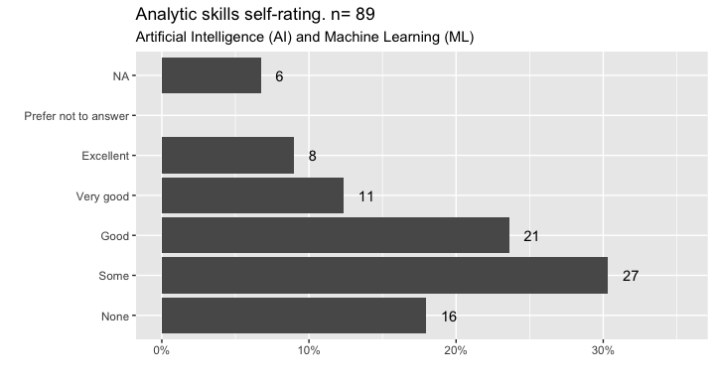

R/Python programming
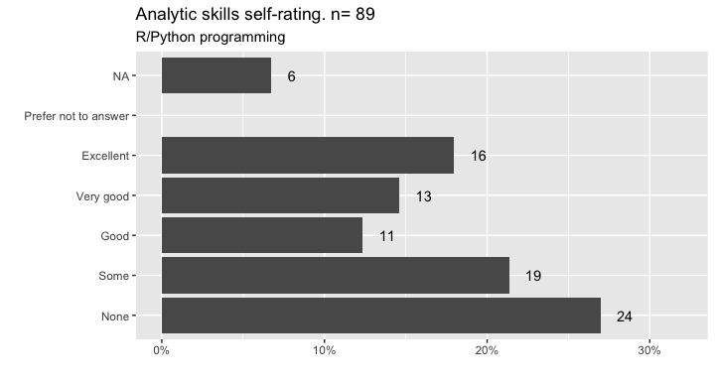

Cloud Computing/HPC environments
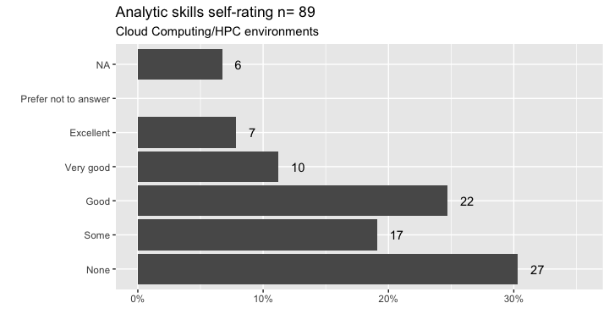

Analytic skills self-rating, together
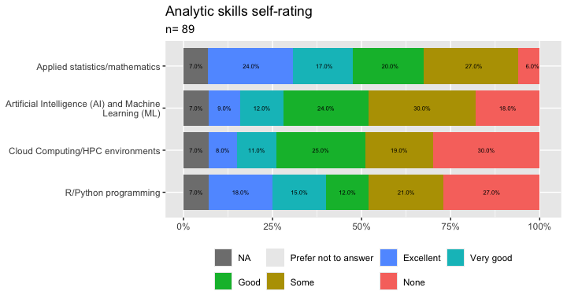

Analytic skills together (only non missing)
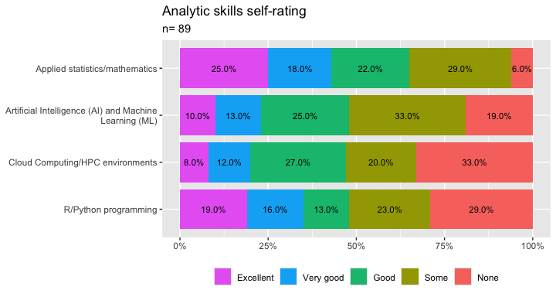

Are you Australia-Based or overseas?
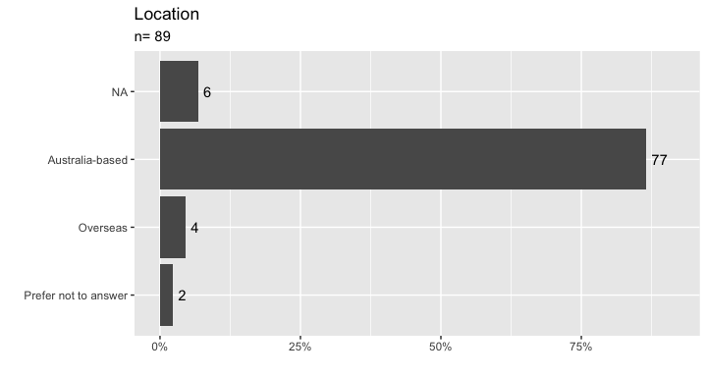

Prior to completing the survey questions, would you like to provide open-ended recommendations regarding the development of the Advanced Analytics and AI resource hub for research in health?
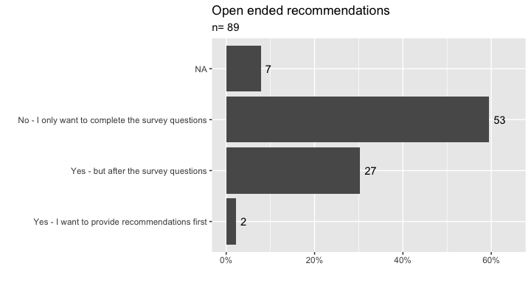

Do you now want to complete the survey questions?
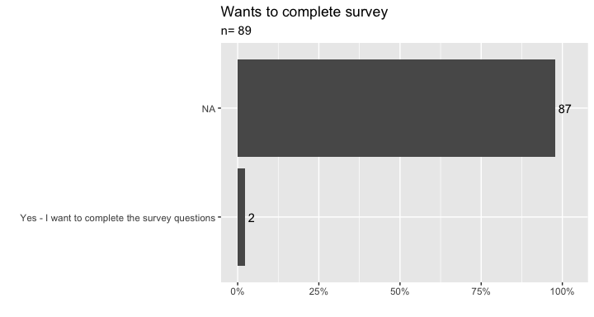

The next section asks about the digital health data you use in your research and what barriers to access you experience. Would you like to answer the questions in this section
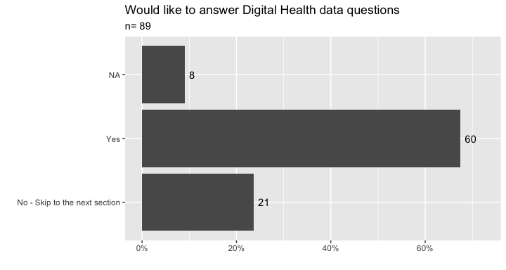

Data Assets and access

The next section asks about the digital health data you use in your research and what barriers to access you experience. Would you like to answer the questions in this section?

For each of the types of digital health data assets listed below, please indicate if you ‘currently use’, ‘want to use’ or ‘neither use nor want to use’?

Electronic health records (EHRs) and clinical notes
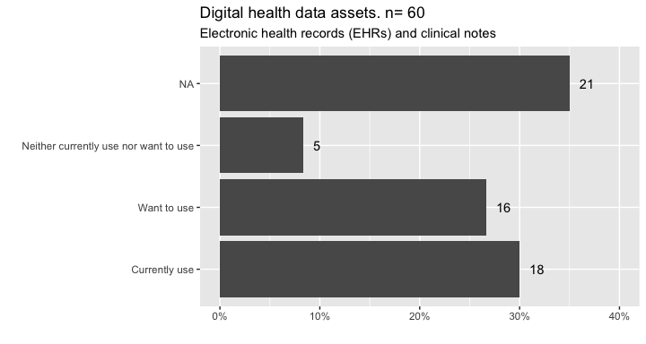

Medical imaging (MRI, CT, ultrasound, pathology images)
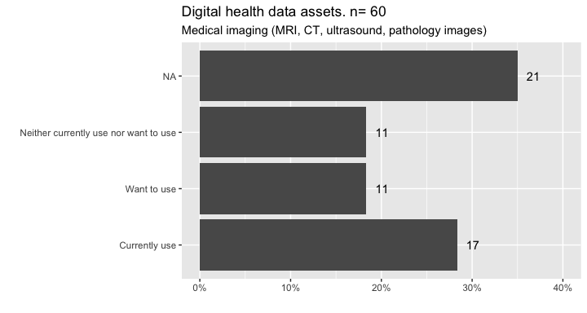

omics data
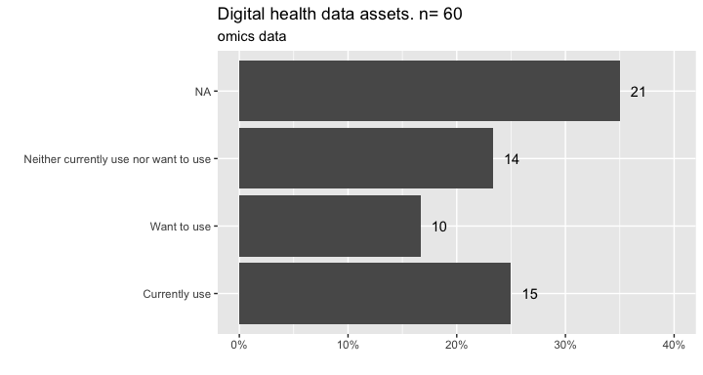

Cancer or disease registries (e.g., QCR, other registries)
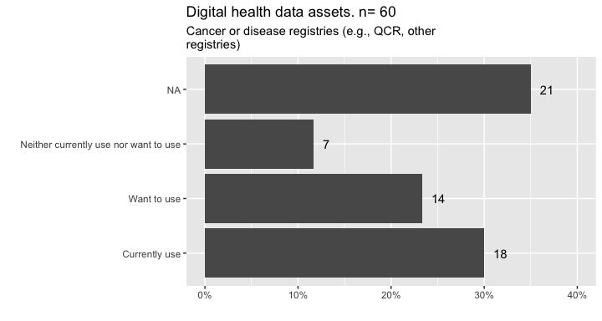

Longitudinal cohort datasets (e.g., UK Biobank, large population cohorts)
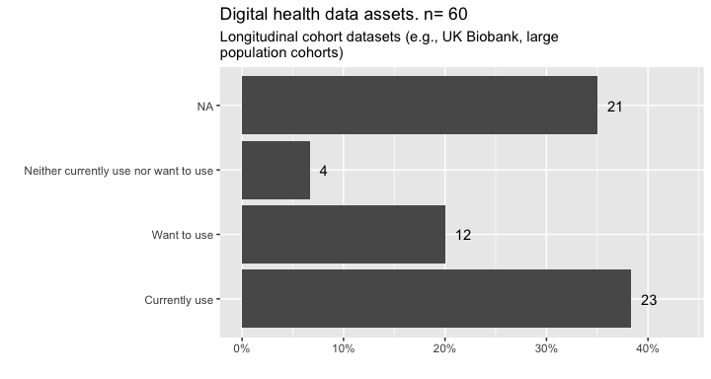

linked data
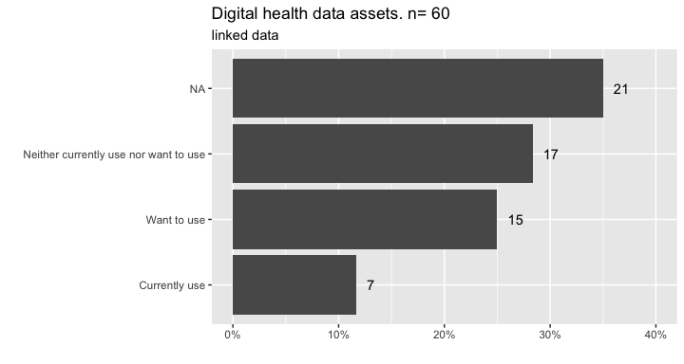

Public health / administrative datasets (e.g., hospital separations, MBS/PBS)
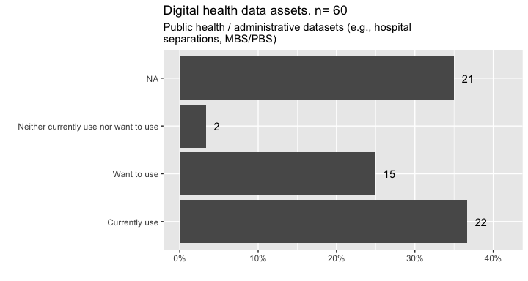

Indigenous data
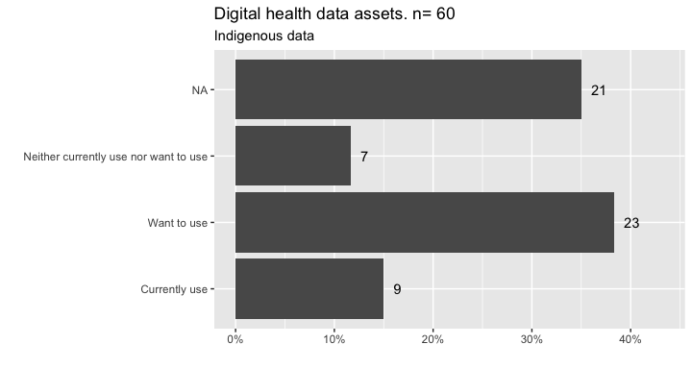

Open research datasets (e.g., SRA, OpenNeuro, publicly available repositories)
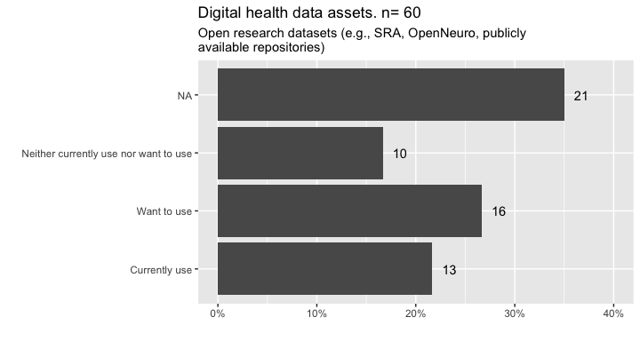

Synthetic data (please specify)
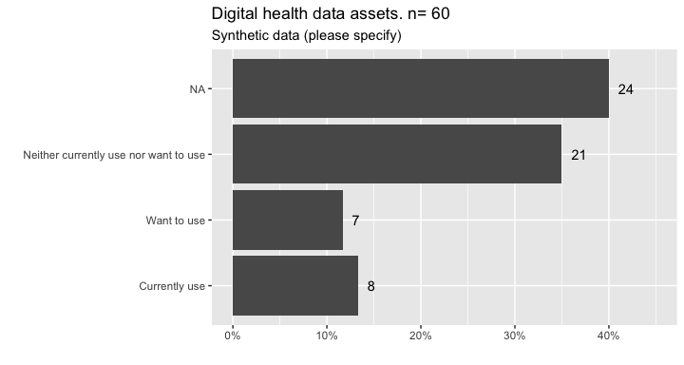

And these are the specific types of synthetic data expressed.
Data.type | Use
Data.type | Currently use | Want to use | Neither currently use nor want to use | Missing | Total
clinical coding data in eHrRol | 1 | 0 | 0 | 0 | 1
need tools for this | 0 | 1 | 0 | 0 | 1
PBS | 0 | 1 | 0 | 0 | 1
Self generated synthetic data | 1 | 0 | 0 | 0 | 1
Sport and Genomics | 1 | 0 | 0 | 0 | 1
We construct our own synthetic datasets, but we'd be interested in others that are available | 1 | 0 | 0 | 0 | 1
We make it using code? | 1 | 0 | 0 | 0 | 1
we simulate data to test approaches sometimes | 1 | 0 | 0 | 0 | 1
Missing | 2 | 5 | 21 | 24 | 52
Total | 8 | 7 | 21 | 24 | 60

Reference Datasets (please specify)
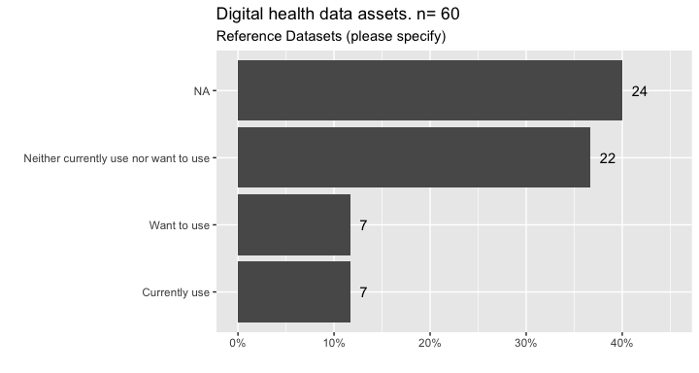

And these are the specific types of Reference datasets expressed.
Reference.data | Use
Reference.data | Currently use | Want to use | Neither currently use nor want to use | Missing | Total
ABS | 1 | 0 | 0 | 0 | 1
ABS data | 1 | 0 | 0 | 0 | 1
adni, UK biobank, aibl | 1 | 0 | 0 | 0 | 1
Genemics from Bioconductor packages | 1 | 0 | 0 | 0 | 1
general population data on service use and diagnoses as comparator for my populaiton of interest | 1 | 0 | 0 | 0 | 1
need local mirrors | 0 | 1 | 0 | 0 | 1
PubMed, Ohsumed, DrugReview | 1 | 0 | 0 | 0 | 1
Missing | 1 | 6 | 22 | 24 | 53
Total | 7 | 7 | 22 | 24 | 60

Linked cross-sector datasets (health + education + social, etc
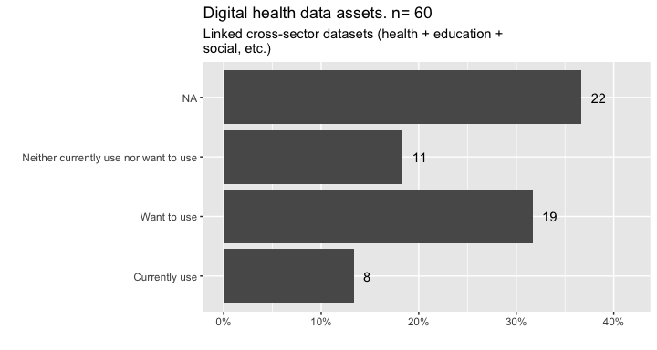

Other
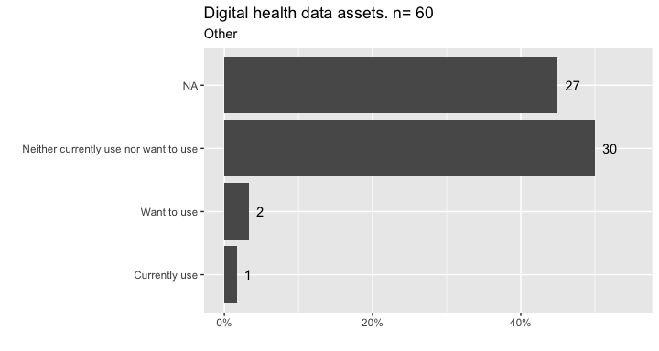

And these are the specific types of Other datasets expressed.
Other.data | Use
Other.data | Currently use | Want to use | Neither currently use nor want to use | Missing | Total
Better hospital admissions data, nationwide, esp private hospital data | 0 | 1 | 0 | 0 | 1
Linked study-specific data | 0 | 1 | 0 | 0 | 1
Missing | 1 | 0 | 30 | 27 | 58
Total | 1 | 2 | 30 | 27 | 60

Digital health assets together
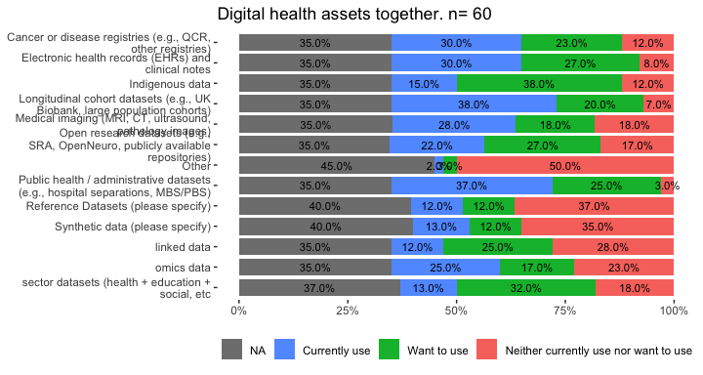

Digital health assets together (No missing)
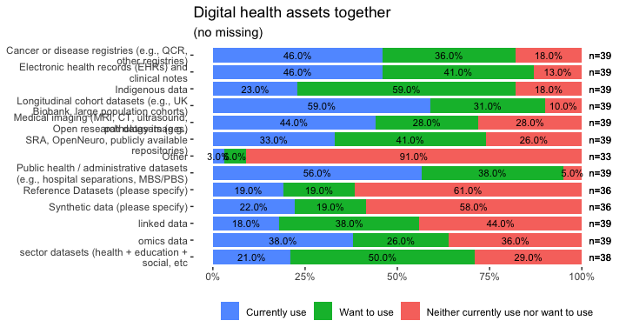

What are the main barriers you face when accessing or using the data you need?
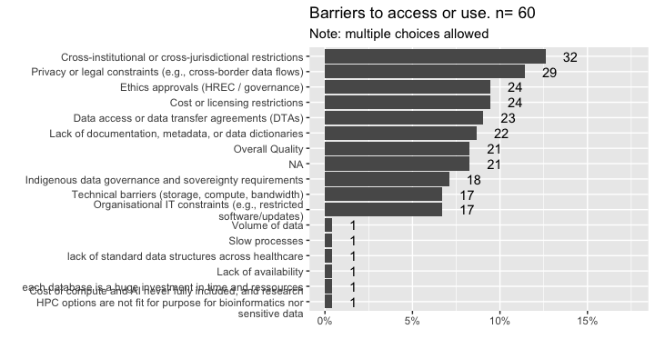
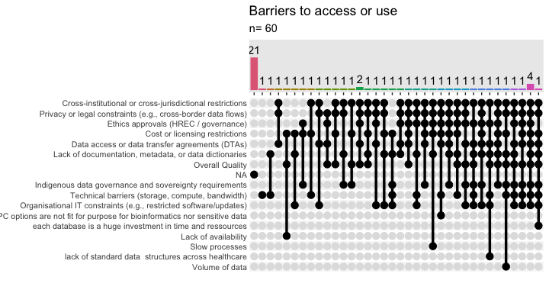

And these are the Other barriers mentioned:
Other.barriers | Use
Other.barriers | Yes | No | Missing | Total
Cost of compute and AI never fully included, and research HPC options are not fit for purpose for bioinformatics nor sensitive data | 1 | 0 | 0 | 1
each database is a huge investment in time and ressources | 1 | 0 | 0 | 1
Lack of availability | 1 | 0 | 0 | 1
lack of standard data structures across healthcare | 1 | 0 | 0 | 1
Slow processes | 1 | 0 | 0 | 1
Volume of data | 1 | 0 | 0 | 1
Missing | 1 | 22 | 31 | 54
Total | 7 | 22 | 31 | 60

What is your level of agreement with the statement “Data Management Tools meet the requirements of my activity”, regarding the items below.

Cost
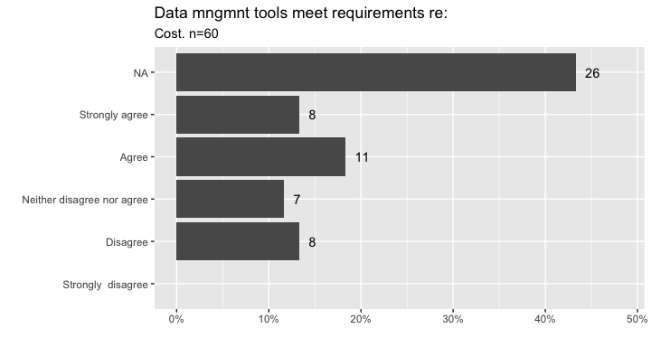

Quality
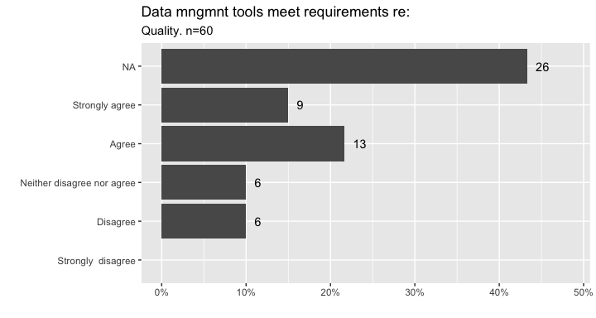

Accessibility/usability
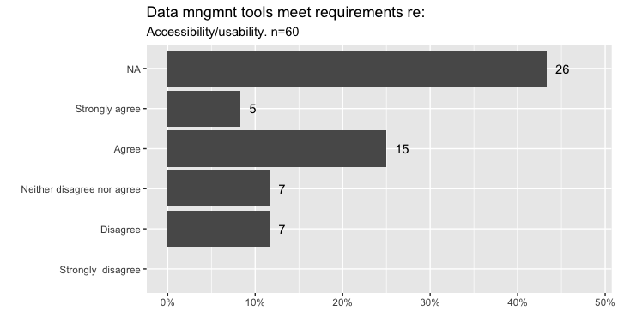

In terms of data cataloguing and metadata
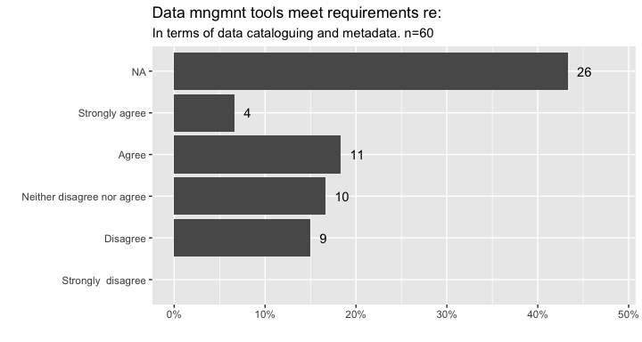

In terms of data validation
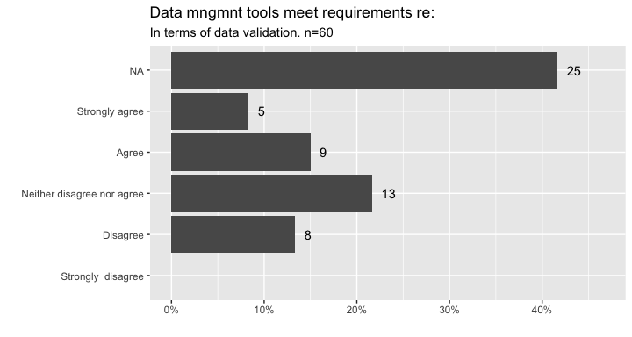

In terms of data integration and harmonisation
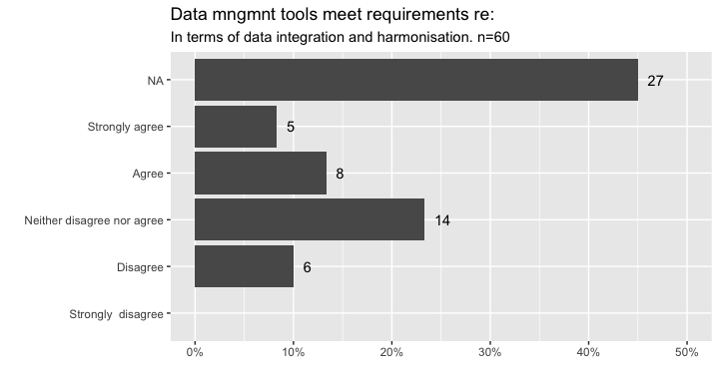

Please rate the importance of the following for your research

Standardised metadata and data dictionaries
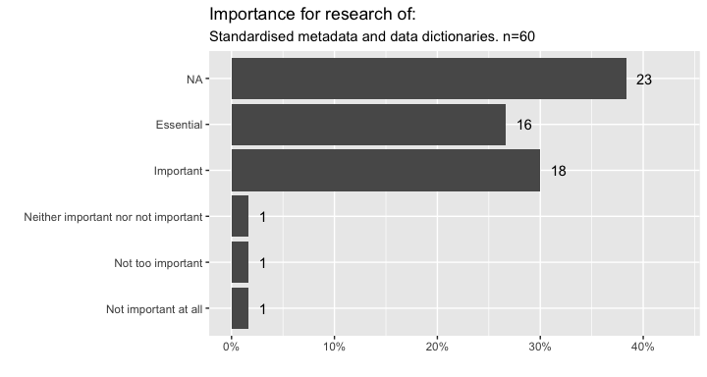

National data harmonisation frameworks
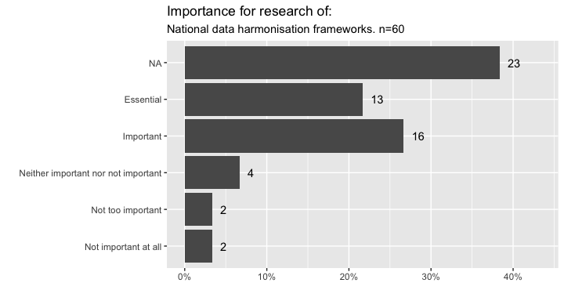

Repeatable, scripted preprocessing/ transformation pipelines
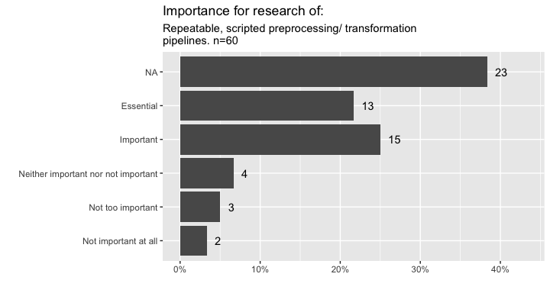

Clear provenance and versioning for datasets
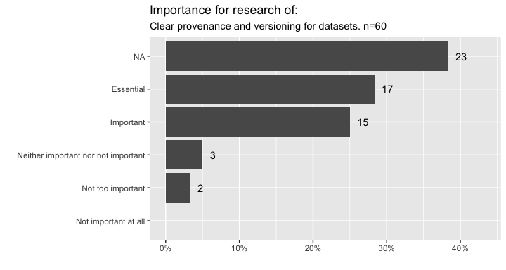

Virtual Research Environments

Are you familiar with Virtual Research Environments (VREs)?
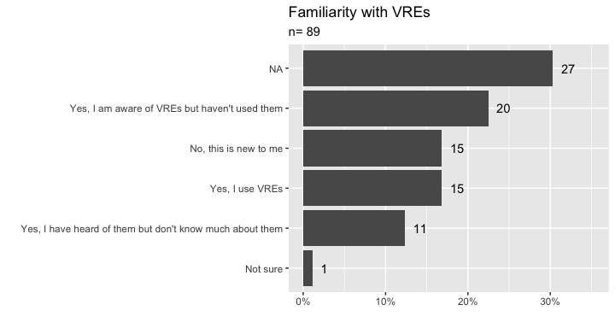

Have you used any of the following types of research environments? (Select all that apply)
Only the 15 that responded Yes I use VREs were given the option to answer which types they had used.
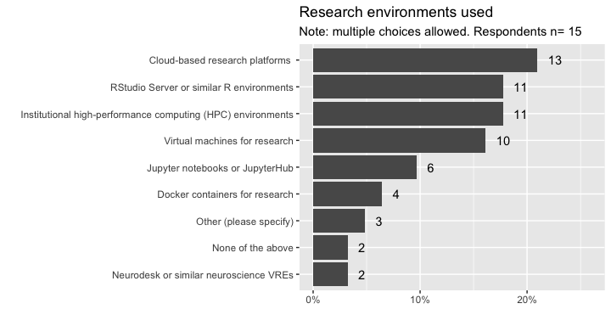

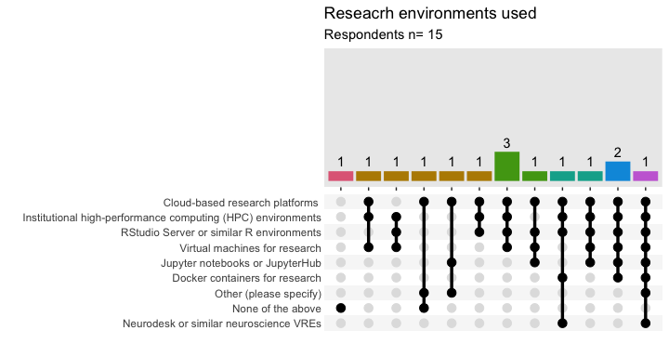

Computer facilities and tools

Would you like to answer questions regarding computing facilities and analytical tools (methods, software or platforms)?
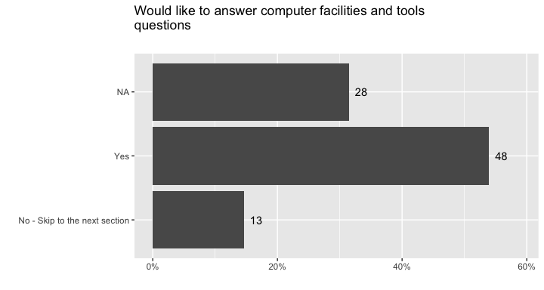

Only those who answered Yes were given the option to answer the next section of questions. Hence the next section is based on 48 respondents only.

Do you currently, or would you like to, use computing facilities outside of your primary desktop or laptop computer?
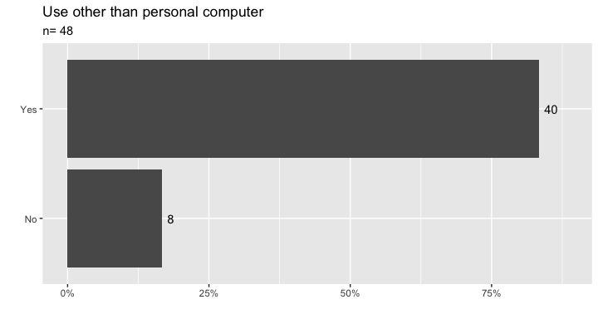

In order to conduct your research, do you currently, or would you like to, access any of the following computing facilities?

Stand alone computer (additional to your primary computer)
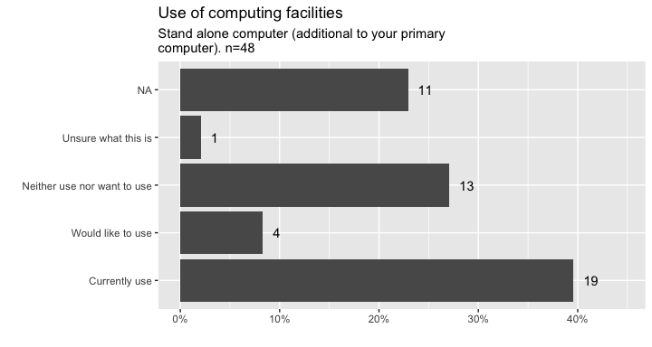

Network connected computer
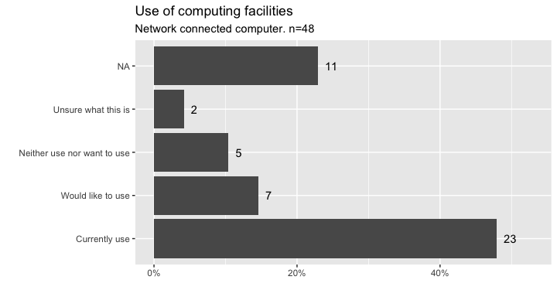

National High Performing Computer (HPC) facilities (e.g. NCI Gadi, Pawsey, ARDC Nectar, etc.)
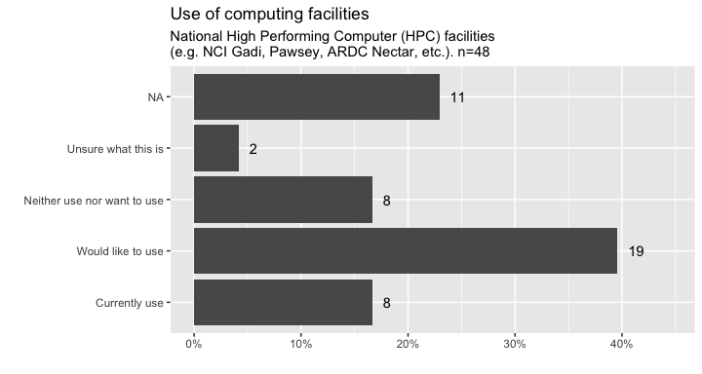

Institutional High Performing Computer (HPC) Facilities
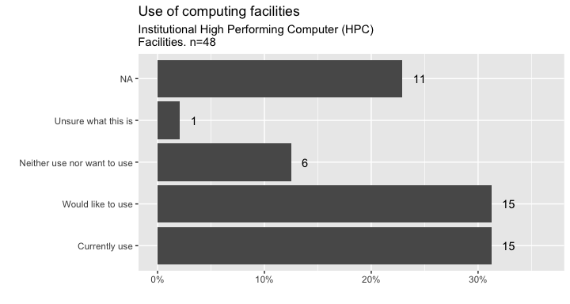

Commercial Cloud (e.g., AWS, Azure, Google, etc.)
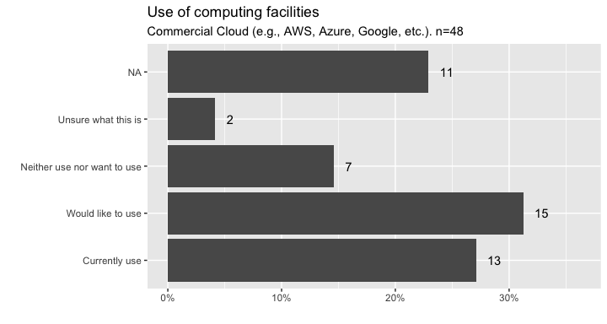
And the Other computer facilities mentioned were
Other | use
Other | Currently use | Would like to use | Total
ABS DataLab | 0 | 1 | 1
Commercial HPC companies (e.g. DUG) | 1 | 0 | 1
commercial vendor TREs | 1 | 0 | 1
Databricks | 1 | 0 | 1
DPUK | 1 | 0 | 1
foreign HPC | 1 | 0 | 1
Total | 5 | 1 | 6

Computer facilities together
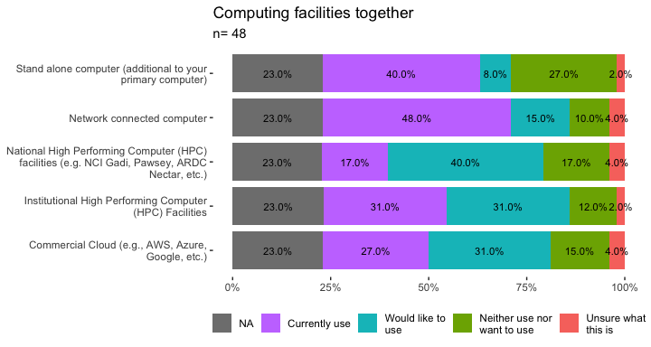

Computer facilities together (no missing)
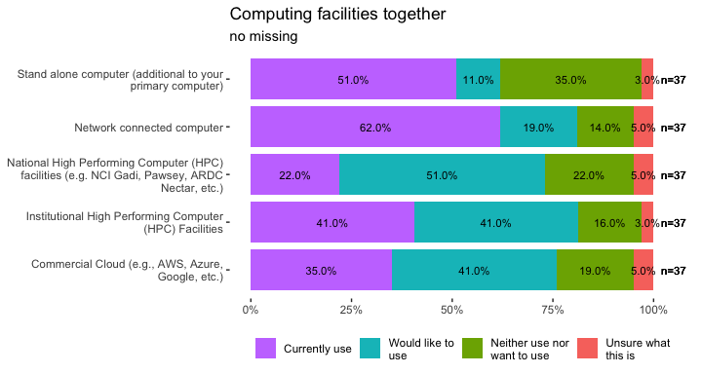

When conducting analytics for your health research, do you use any of the following programming languages/environments, proprietary platforms or data science tools. Please select all that apply. ?

R
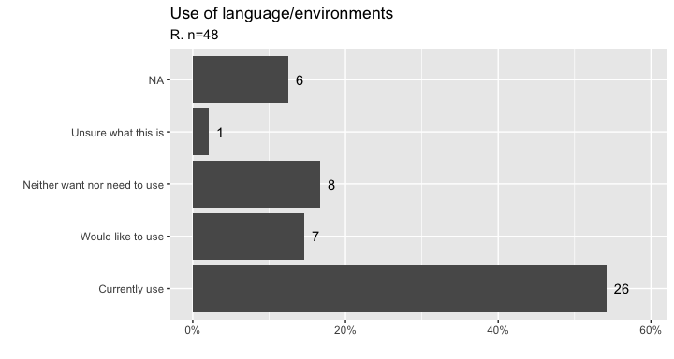

Python
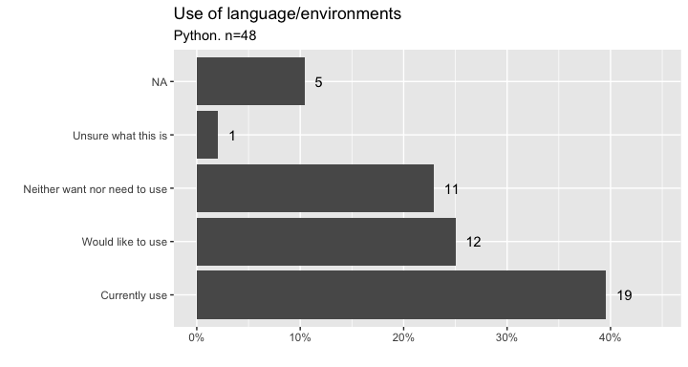

Julia
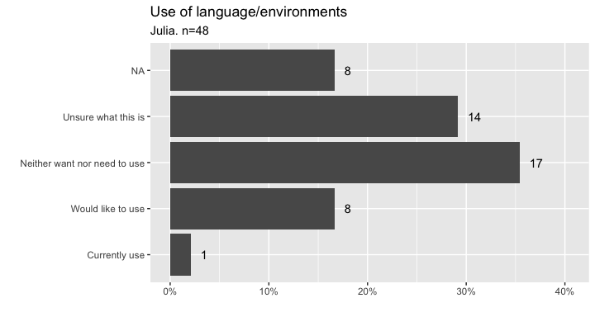

SQL & Database management
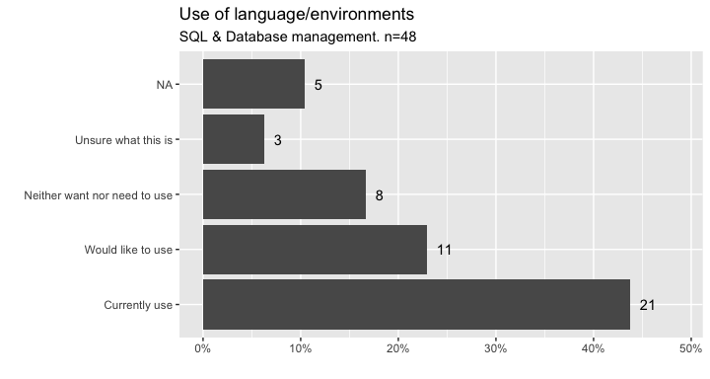

RStudio/Posit (free version)
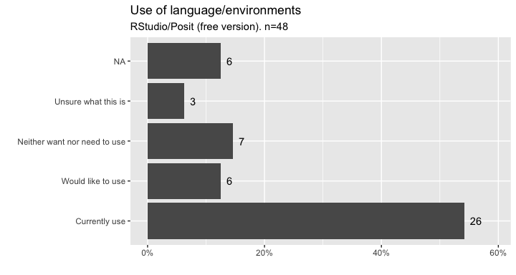

Jupyter Notebooks or Hub
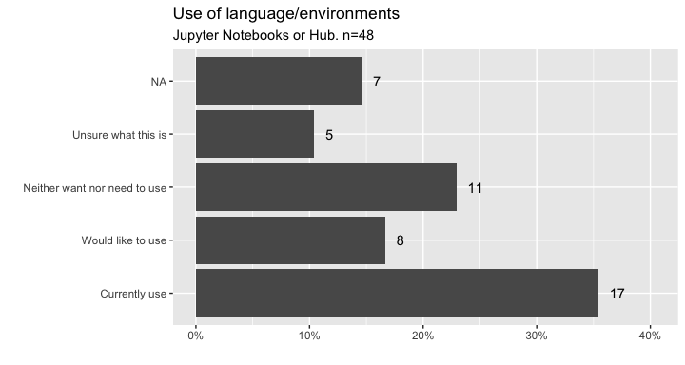

VS Code
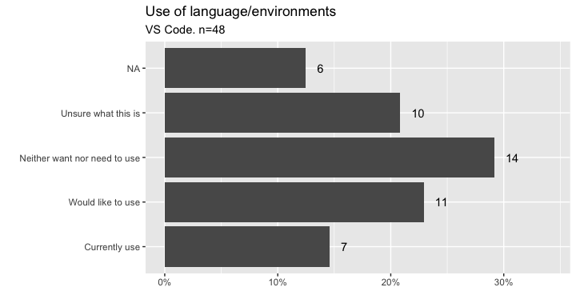

SAS
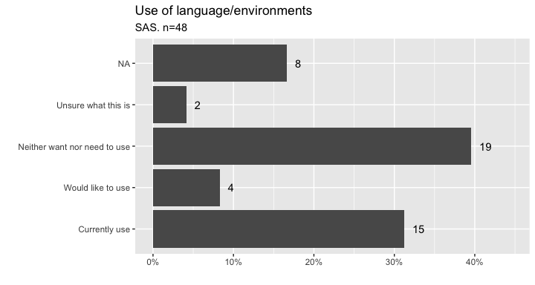

MatLab
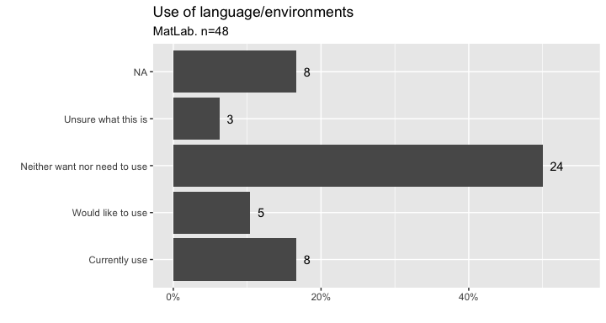

RStudio Pro (paid version)
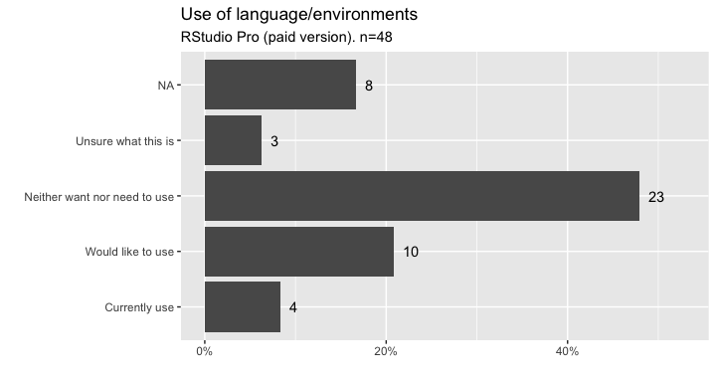

Power BI
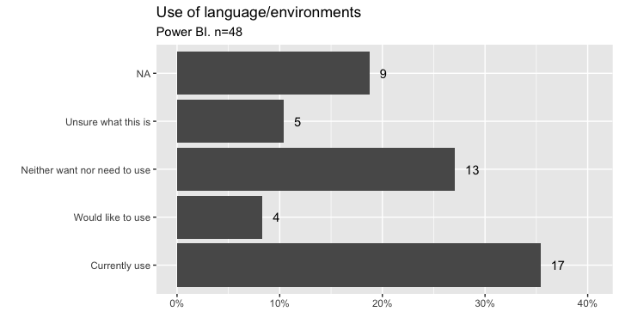

Tableau
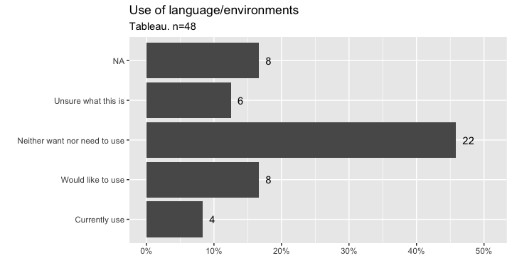

Excel
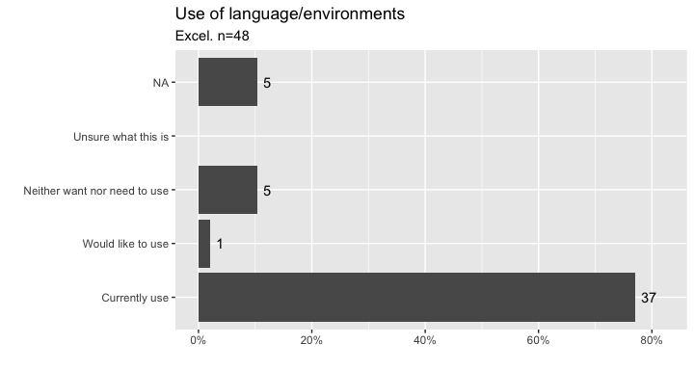

Docker or containers
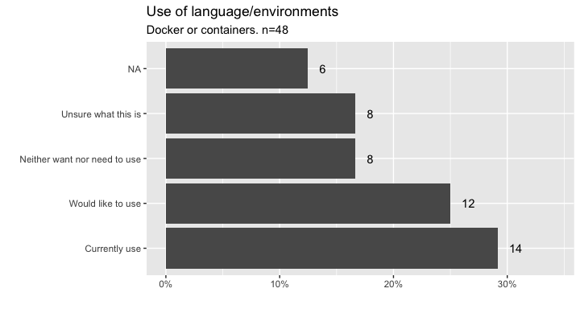

GitLab
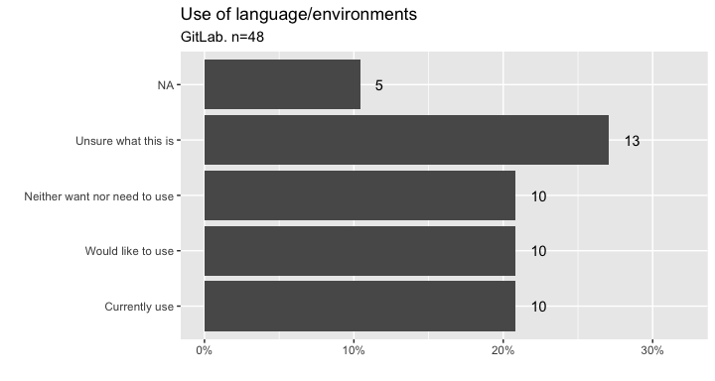

GitHub (free)
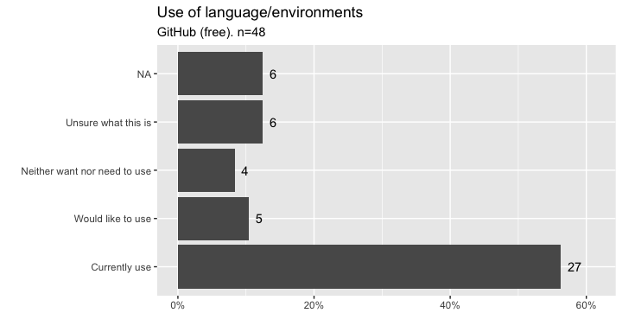

GitHub (paid)
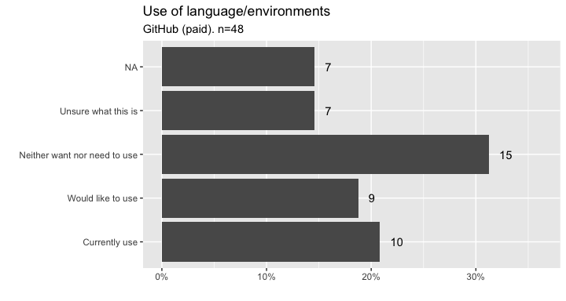

TensorFlow
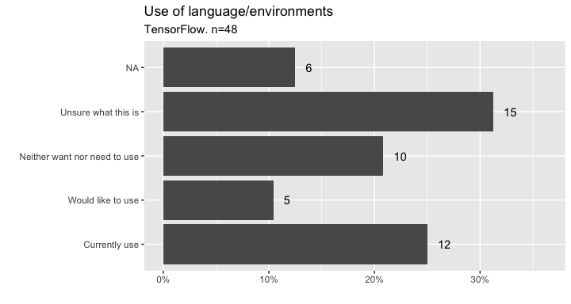

Pytorch
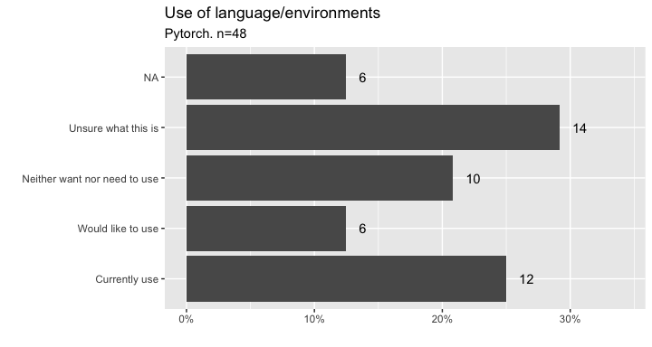

Nextflow
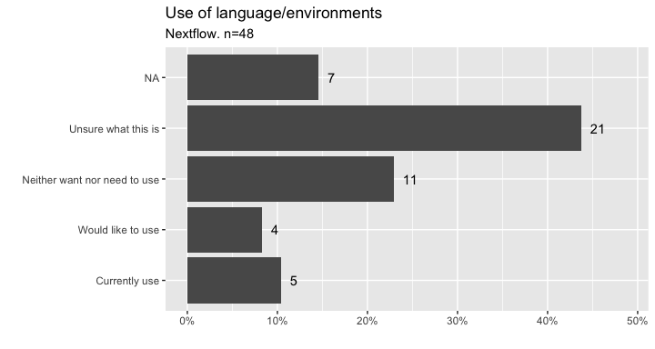

Snakemake
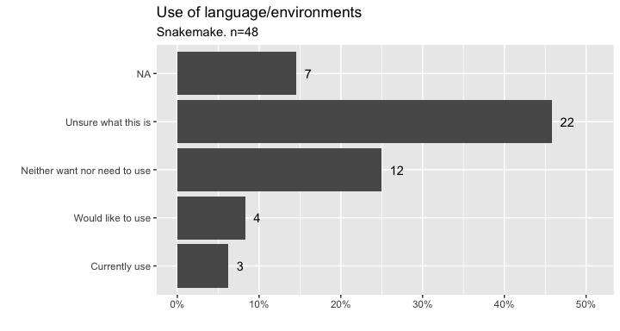

singularity
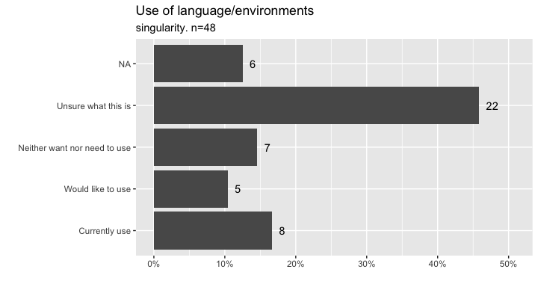

And here are the Other language programs and environments cited by respondents.
Other | use
Other | Currently use | Would like to use | Total
Antigravity (google) | 1 | 0 | 1
C | 1 | 0 | 1
CUDA | 0 | 1 | 1
episerv | 1 | 0 | 1
Fortran | 1 | 0 | 1
Linux command line | 1 | 0 | 1
Mplus | 1 | 0 | 1
MS Office | 1 | 0 | 1
Opendatafit | 1 | 0 | 1
Positron | 1 | 0 | 1
stata | 2 | 0 | 2
Stata | 3 | 0 | 3
Total | 14 | 1 | 15

Tools and programs together
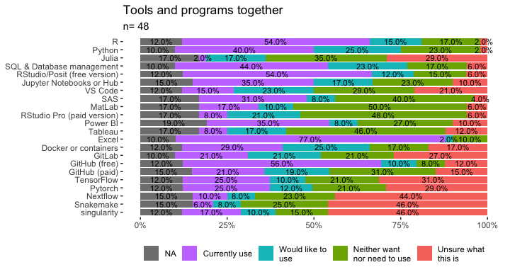

Tools and programs together (no missing)
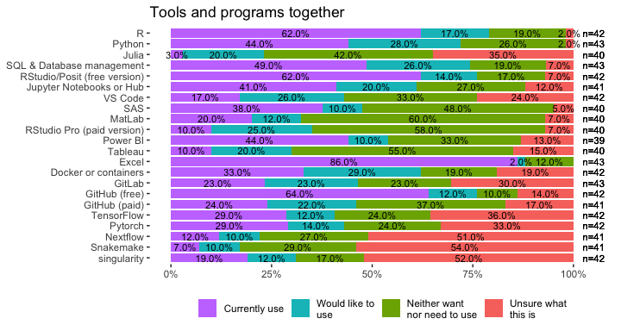

When conducting your research, do you currently use or would you like to use any of the following advanced analytics (AI & non-AI) techniques or methods?

Regression
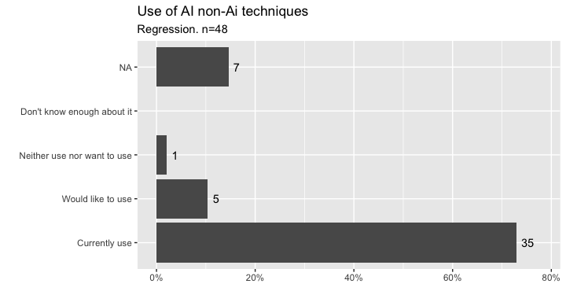

Causal analysis
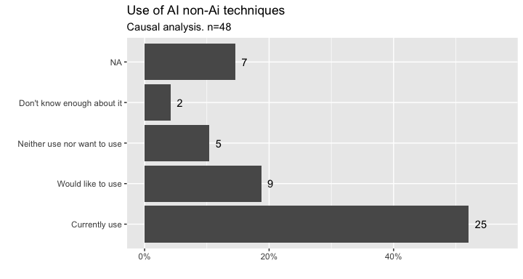

Survival analysis/ time to event modelling
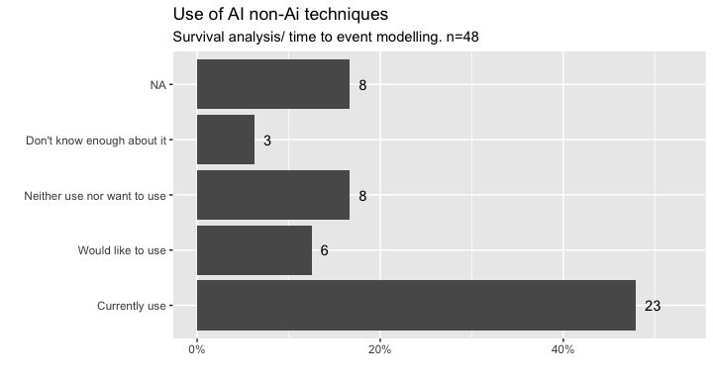

Bayesian statistics
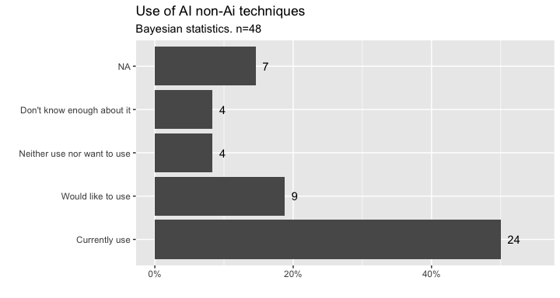

Decision trees/ Random forests
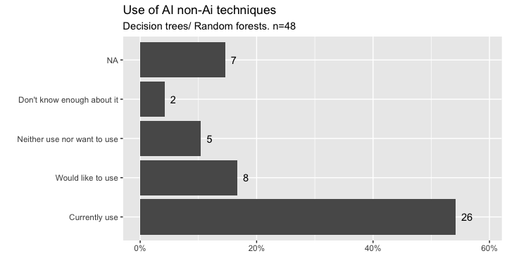

Machine Learning (unsupervised/supervised)
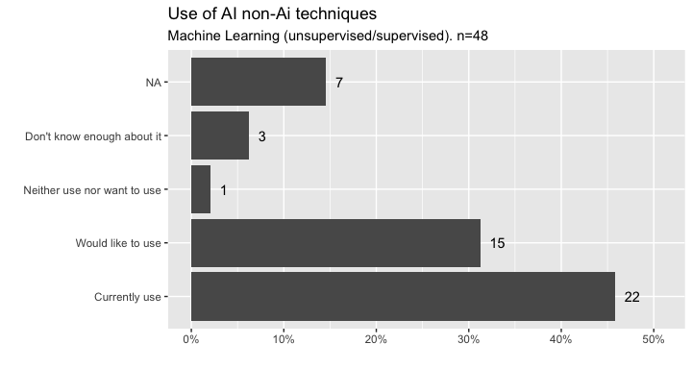

Gradient boosted (XGBoost, LightGBM)
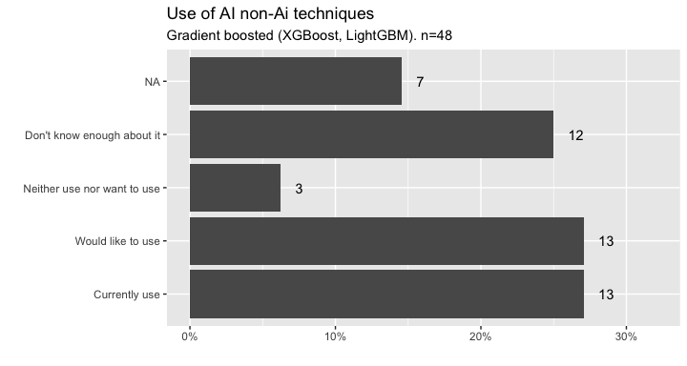

Deep Learning (CNN, RNN)
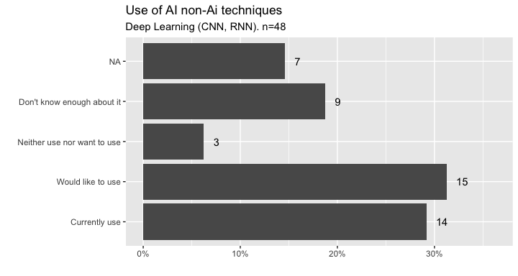

AutoML & Hyperparameter optimisation
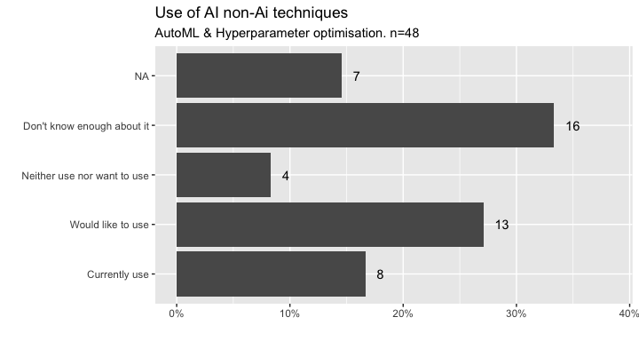

Model interpretability/ explainability
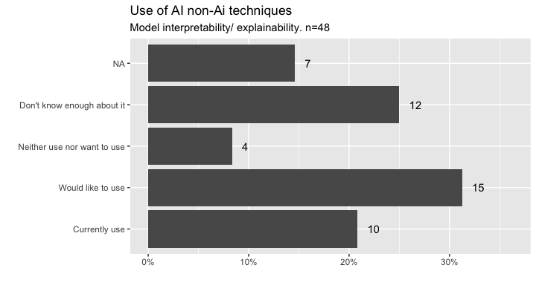

Natural language processing models
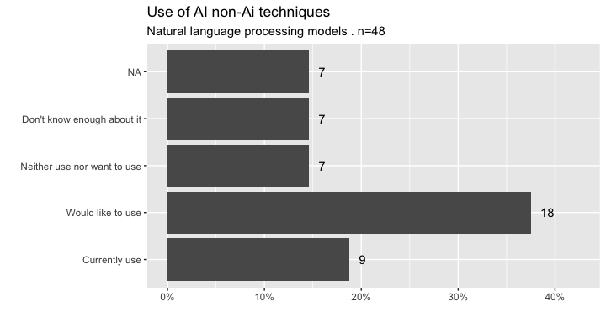

Clustering or pattern recognition models
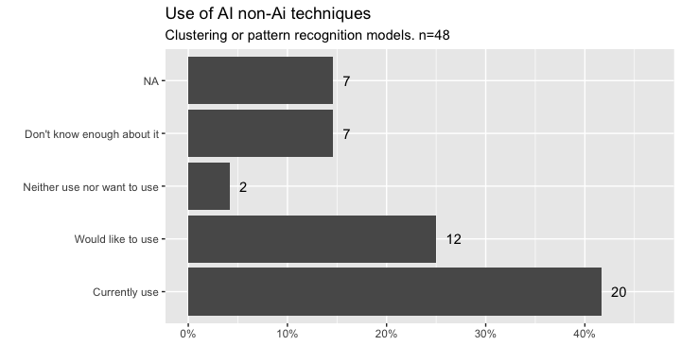

Federated learning models or distributed AI frameworks
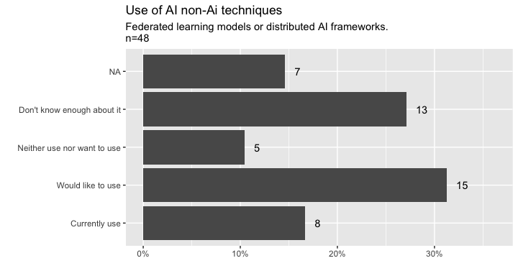

Graph neural networks and knowledge graphs
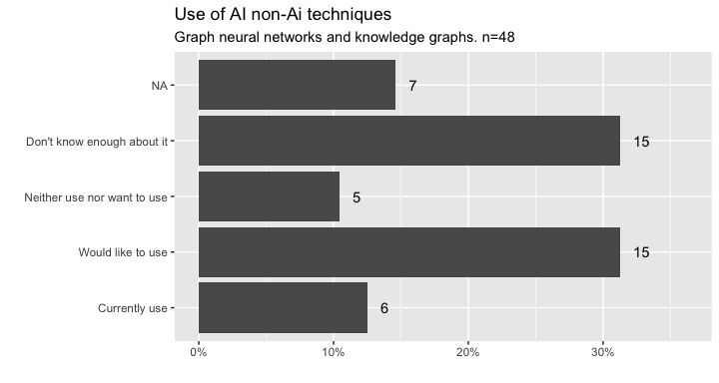

Network analysis
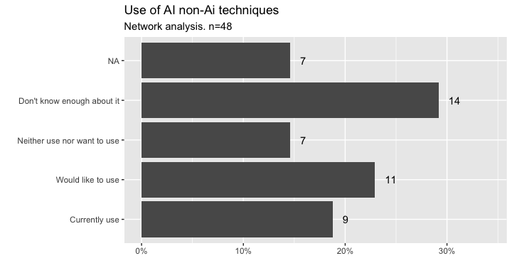

Preserving ML
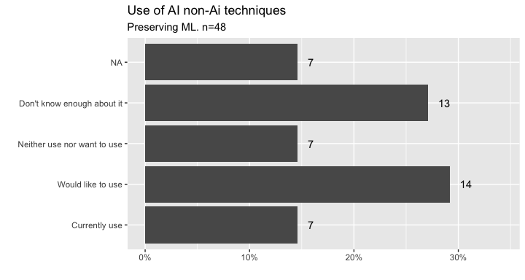

Reinforcement Learning & Adaptive Interventions
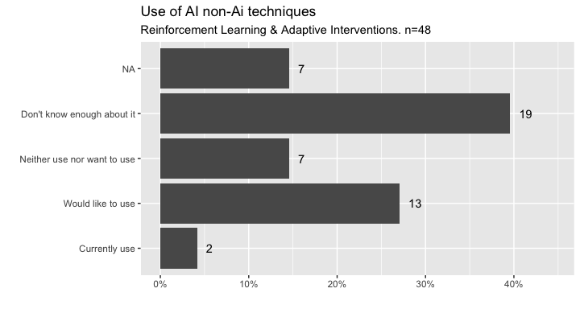

Natural language processing models
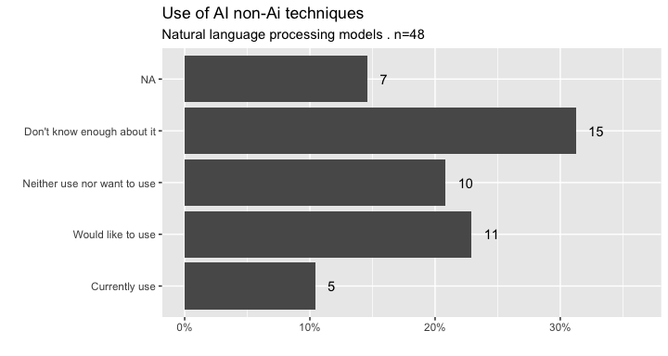

Low Code No Code Tools in ML
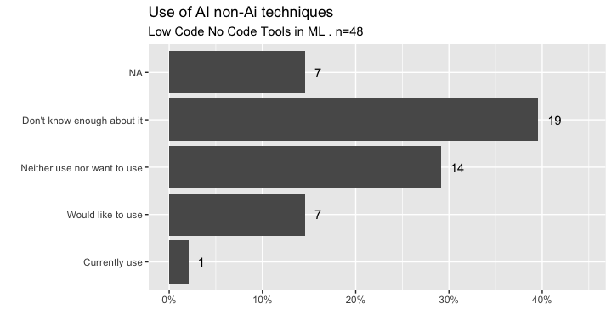
And these are the Other AI & Non-AI techniques mentioned by respondents.
Other | use
Other | Currently use | Would like to use | Total
Any graphical representation of results | 0 | 1 | 1
Bayesian optimisation | 1 | 0 | 1
Genome language models (e.g. AlphaGenome, Enformer etc) | 1 | 0 | 1
Total | 2 | 1 | 3

AI non-Ai techniques together
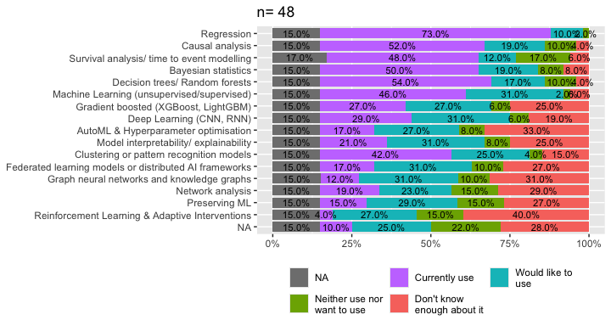

AI non-Ai techniques together (no missing)
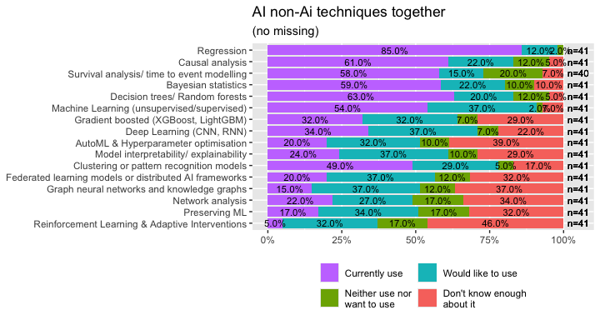

When conducting your research, do you use or would you like to use any of the following domain-specific health analytics tools or methods?

Omics integration methods
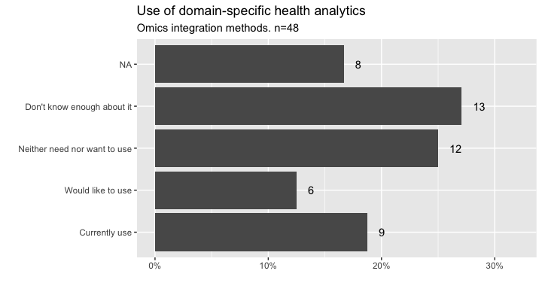

Electronic Health Records (EHR) analytics
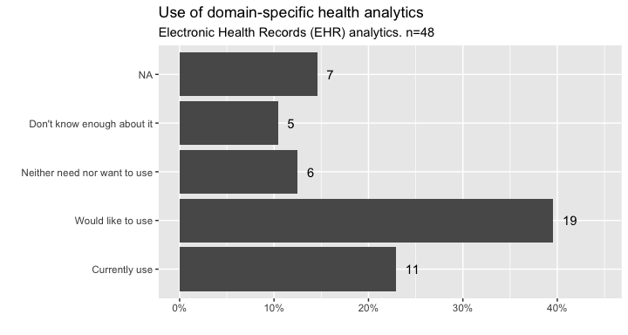

Clinical trial design and analysis
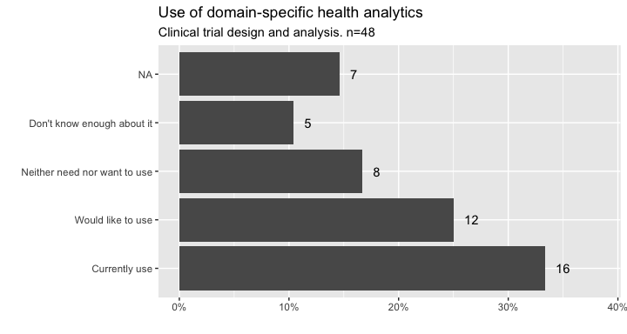

Computer Vision & Medical Imaging Analysis
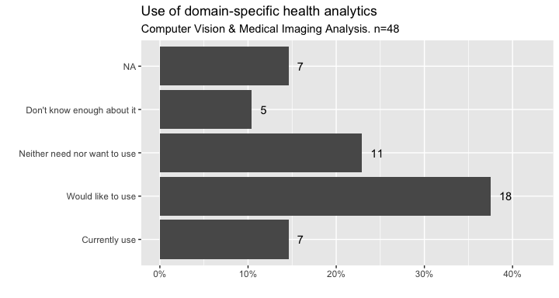

Community engagement methods
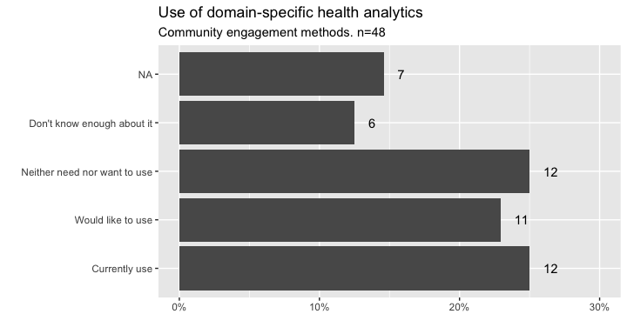

Galaxy
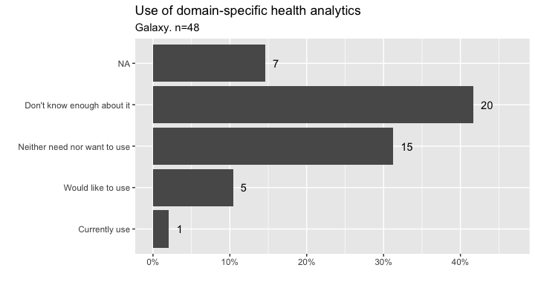

BioConductor
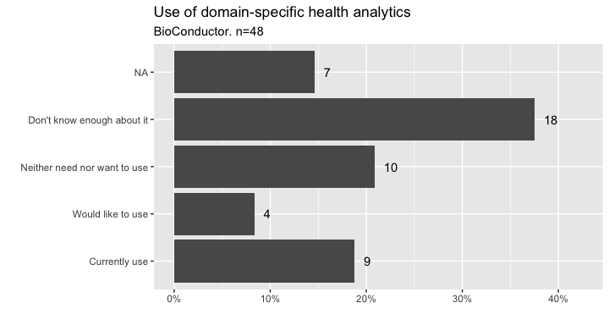

WGCNA
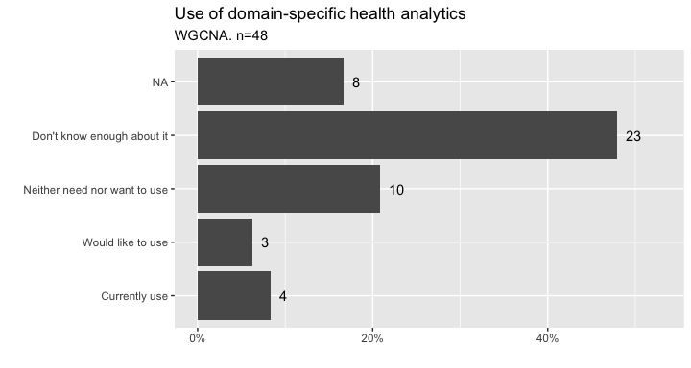

Neurodesk
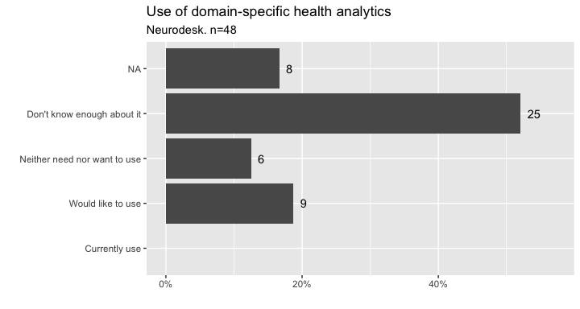
And these are the Other Health domain-specific analytics mentioned by respondents.
Other | use
Other | Currently use | Would like to use | Total
mass spectrometry data | 1 | 0 | 1
NMR data | 1 | 0 | 1
plate reader data | 1 | 0 | 1
Total | 3 | 0 | 3

Domain-specific health analytics together
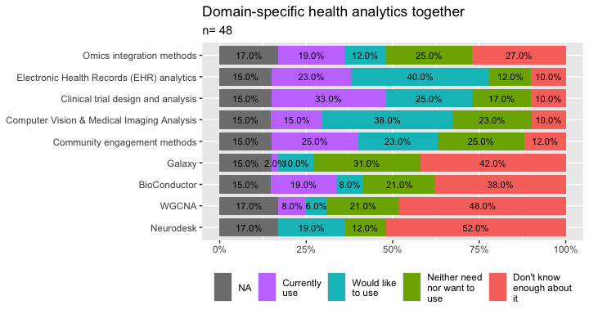

Domain-specific health analytics together (no missing)
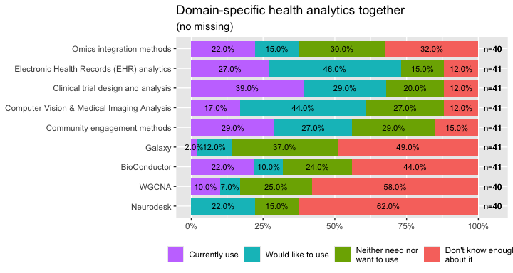

Do you currently use, or would like to use, any of the following GenAI & LLM tools to support your research?

Claude (paid)
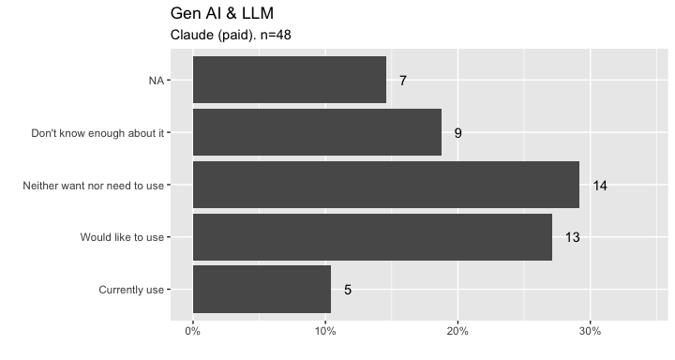

Claude (free)
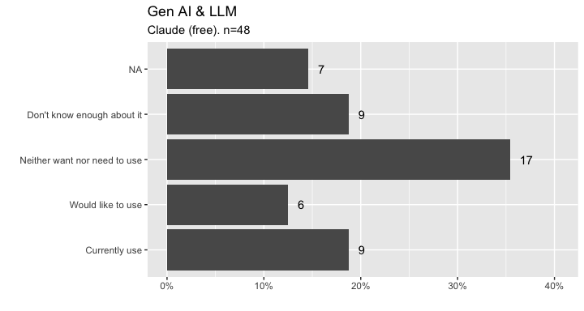

ChatGPT (paid)
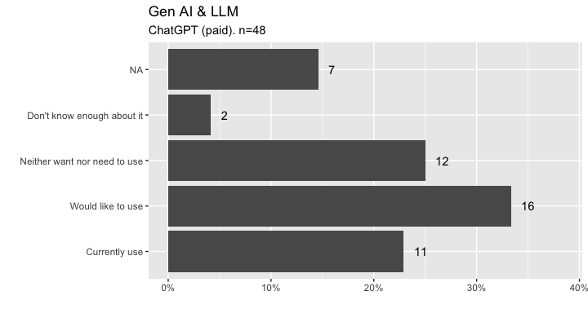

ChatGPT (free)
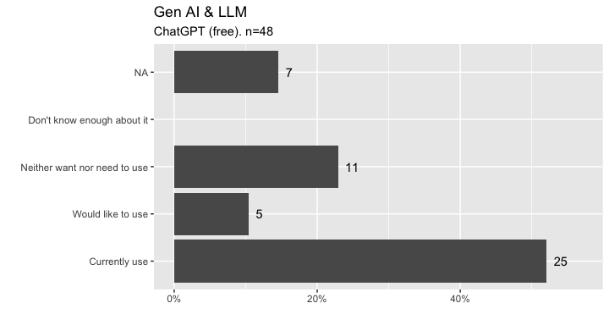

Sandbox instances of LLMs
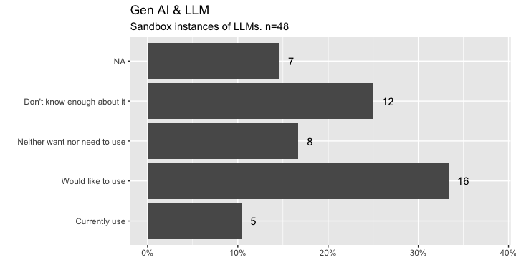

Microsoft Copilot
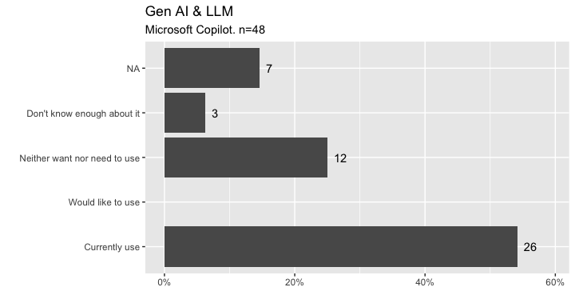

pilot
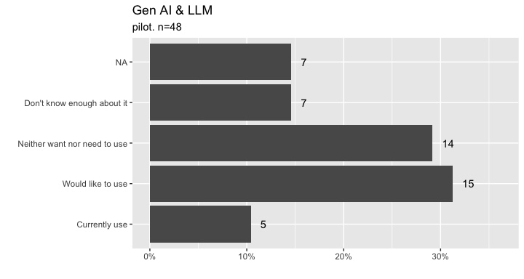
And these are the Other GenAi & LLM mentioned by respondents.
Other | use
Other | Currently use | Would like to use | Total
Gemini | 1 | 0 | 1
google gemini | 1 | 0 | 1
Google Gemini | 1 | 0 | 1
Grok | 1 | 0 | 1
le chat (mistral) | 1 | 0 | 1
mistral | 1 | 0 | 1
nexa | 1 | 0 | 1
NotebookLM | 1 | 0 | 1
ollama | 1 | 0 | 1
perplexity | 1 | 0 | 1
Prism | 1 | 0 | 1
Research Rabbit | 1 | 0 | 1
Total | 12 | 0 | 12

GenAI & LLM tools together
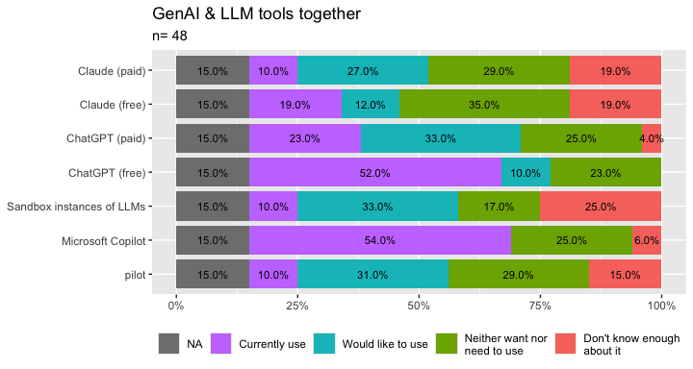

GenAI & LLM tools together (no missing)
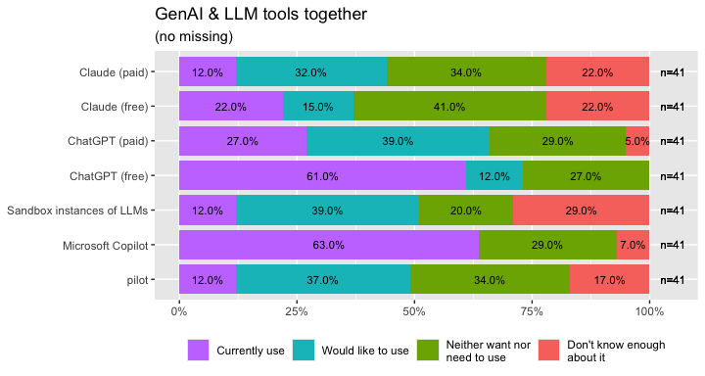

Frequency of use, limitations and challenges of Computing tools used

How often do you use the following resources for your health research analytics?
There were 48 respondents for the computing facilities and tools section. Of those, this section asks for the frequency of use for the tools that were classified as Currently use.

Stand alone computer (additional to your primary computer)
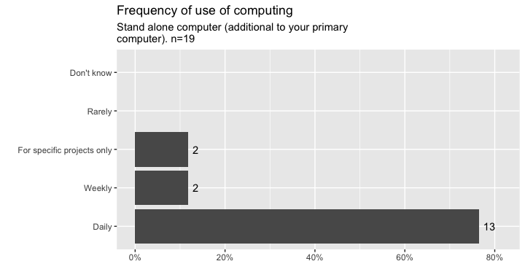

Network connected computer
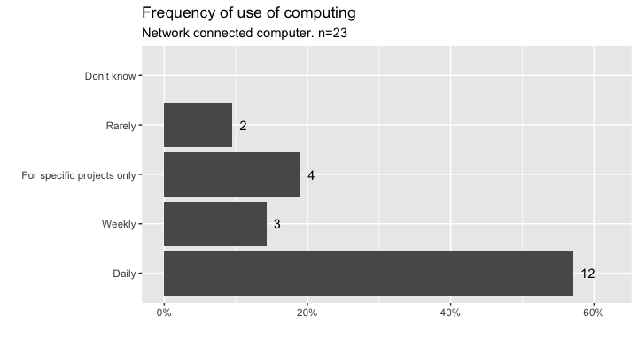

National High Performing Computer (HPC) facilities (e.g. NCI Gadi, Pawsey, ARDC Nectar, etc.)
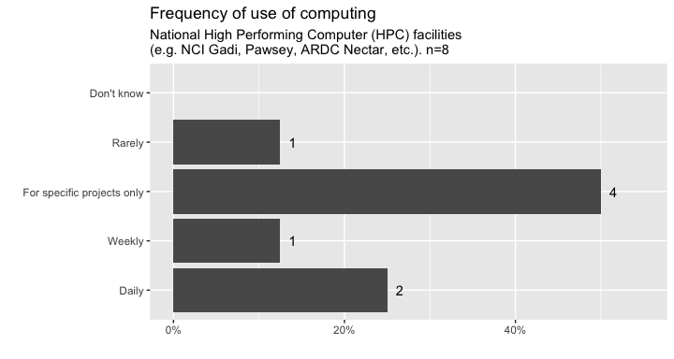

Institutional High Performing Computer (HPC) Facilities
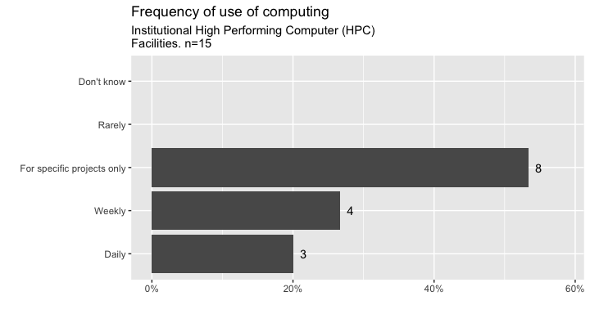

Commercial Cloud (e.g., AWS, Azure, Google, etc.)
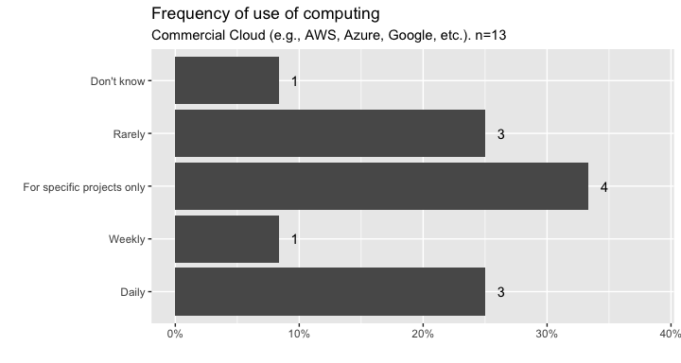

Other
This is the list of the frequency for other tools.
Other | Frequency
Other | Daily | Weekly | For specific projects only | Rarely | Don't know | Total
Commercial HPC companies (e.g. DUG) | 0 | 1 | 0 | 0 | 0 | 1
commercial vendor TREs | 1 | 0 | 0 | 0 | 0 | 1
Databricks | 0 | 1 | 0 | 0 | 0 | 1
DPUK | 0 | 0 | 1 | 0 | 0 | 1
foreign HPC | 0 | 0 | 1 | 0 | 0 | 1
Total | 1 | 2 | 2 | 0 | 0 | 5

Frequency of use All together
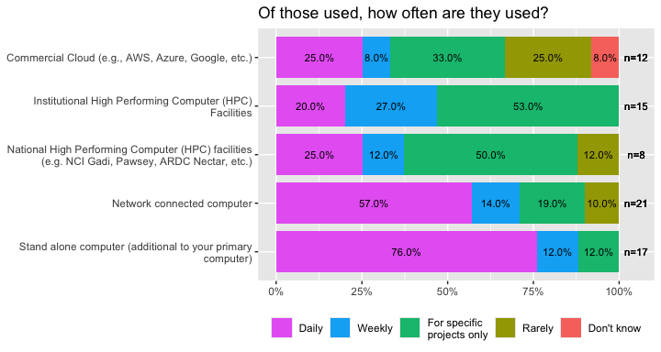

What are the main limitations or challenges you face with the computing facilities you use?
As a note, these following questions were only asked to respondents who responded to any of the computing facilities/tools questions
What are the main limitations or challenges you face with the computing facilities you use? (if none, write “none”) | count
Access to gpu | 1
Cannot use HPC with sensitive health data. Need to choose tools that colleagues can also use/understand. Limited RAM and performance with virtual analysis environments. Slow data ingress/egress (curation). | 1
Cost of compute. | 1
Each different (learning curve), most have limitations in computing or environment constraints. | 1
HPC and national resources typically not appropriate for health data, not appropriate for sensitive data. No certifications at all, which is required for certain datasets. Lots of piecemeal setups with nothing sustainable or maintainable | 1
Institutional access, expertise | 1
Insufficient RAM and CPU | 1
Limited knowledge of best facilities/programs to use.  Institution-based limits of what can be used when working with sensitive health data | 1
Memory limitations and limit advanced visualisation | 1
Neea a job environment | 1
n: 19

Have you experienced any technical challenges that have resulted in you using compute facilities less than you would like?
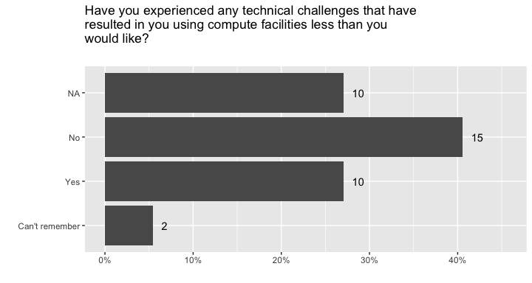

Have any of the following technical challenges limited your use of computing facilities you intended to use?

Installation or licensing issues (e.g., difficulties with software setup, license procurement, or renewal.)
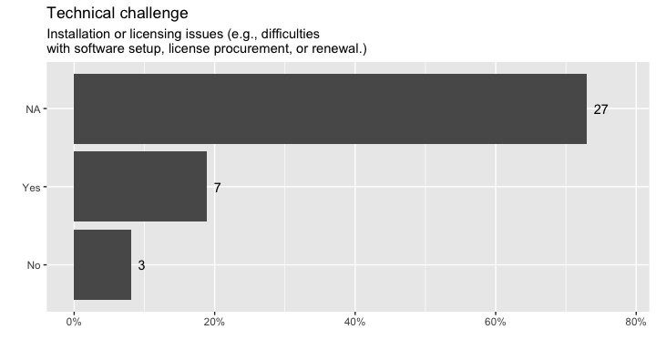

Constraints in training or availability of data
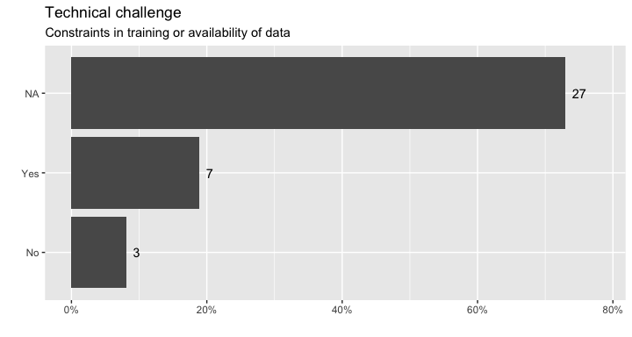

Limited access to expertise or skilled personnel
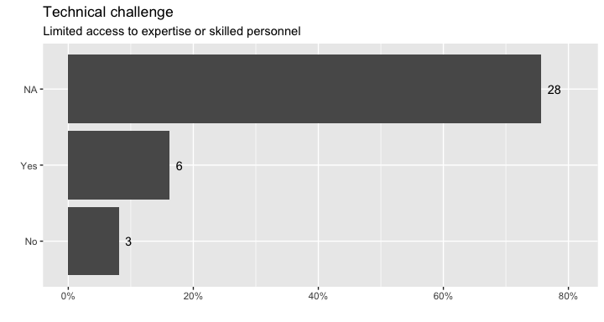

Concerns about IP or ICIP leakage?
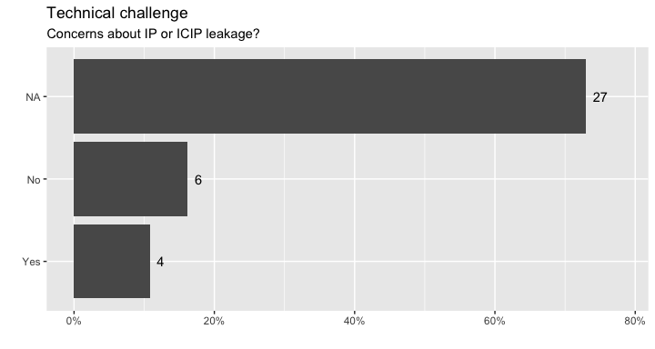

Platform compatibility problems (e.g., tools not integrating well with existing systems or workflows.)
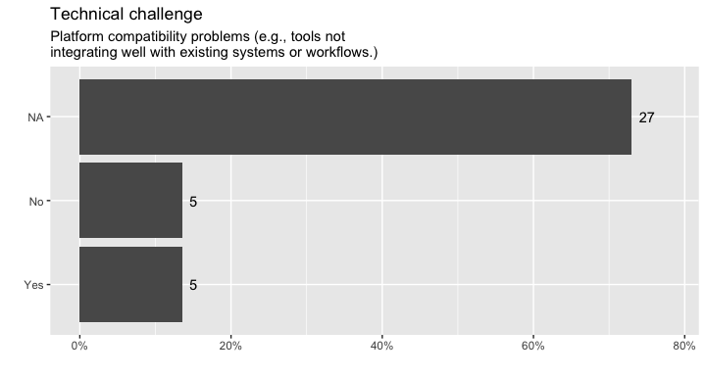

Limited access to compute resources (e.g., GPUs, inability to run large models due to hardware constraints.)
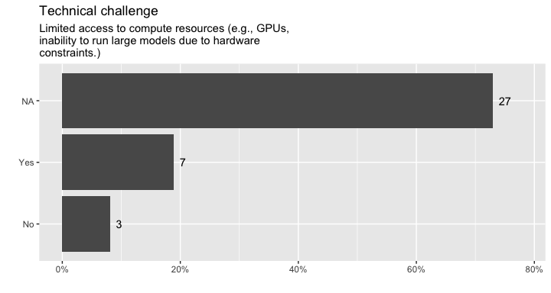

Other (please specify):
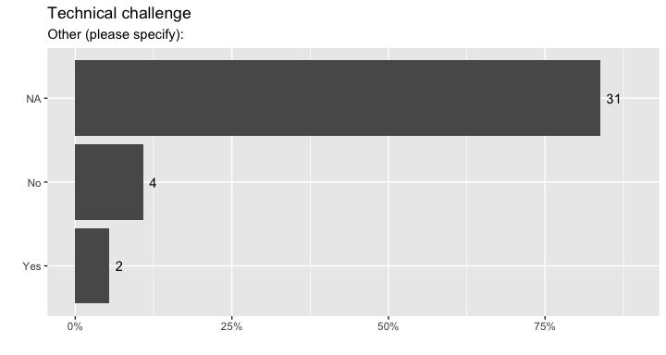

And these are the Other technical challenges cited.
q40_7_text | q40_7
q40_7_text | Yes | No | Total
lack of certifications apprpriate for housing senstive data. no interest in health data (seen as too big a risk), with inappropriate compute by design (ie built of non-senstive data use cases with shared compute) | 1 | 0 | 1
Require trained statisticians who know how to compute | 1 | 0 | 1
Total | 2 | 0 | 2

Technical challenges together
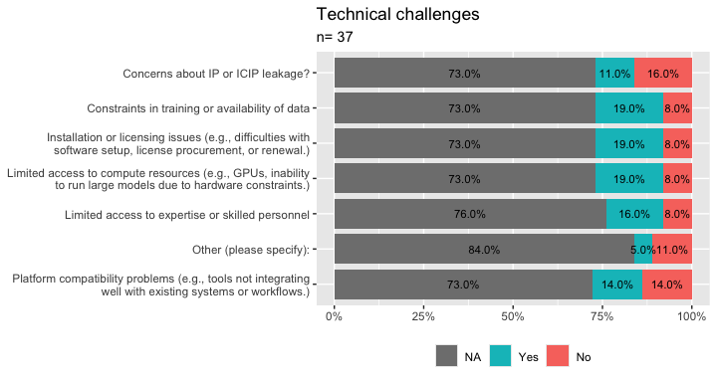

Technical challenges together (no missing)
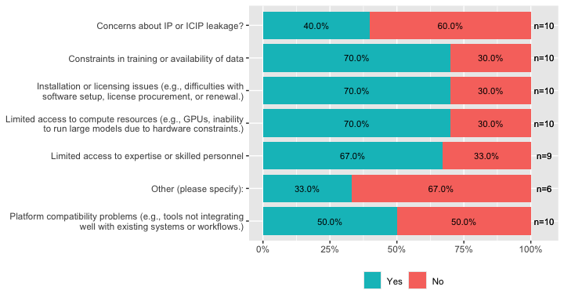

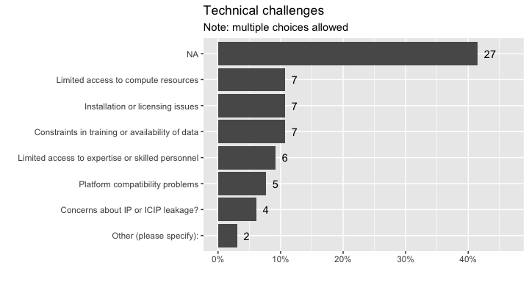
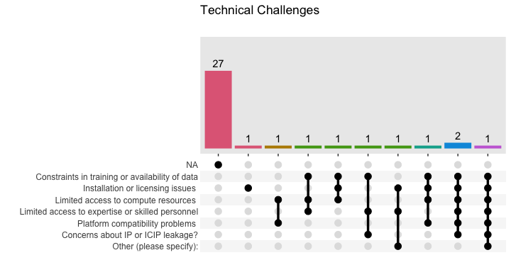

For any computing facilities you indicated you ‘would like to use’ for your research, please share with us the reasons why. Please consider: Specific computing power, data handling, parallelisation, ease of use, or any other reasons you may have.
These following answers are for those who said they would like to use to any of the computing facilities and tools.
Stand.alone.computer..additional.to.your.primary.computer.
High performance computers for simulations
Higher computing power, separate setup from everyday working
National High Performing Computer will help me to increase my sample size using real or synthetic data.
Commercial Cloud will help me to deploy packages and websites.
Overall, using a combination of these computing facilities ensures flexibility, scalability, and efficiency, allowing my research to progress effectively while meeting the computational requirements of advanced machine learning experiments.
n: 4

WP Tools and Platforms Analytics (AI and non-AI) 3.1 & 4.1 by Demand, Importance and Impact

Executive Summary
Work projects 3 and 4 had as deliverables 3.1 and 4.1, after elicitation, a list of Analytics platforms and tools to be classified based on 3 characteristics: Demand, importance and potential impact. The measure of such characteristics is based on the information gathered from the survey. The context of these lists and findings is to help inform the consideration of tools and platforms by the ARDC for the implementation and inclusion of these in the proposed analytics hub and VREs.
Based on the 89 survey responses, the platforms and tools assessed included: Computing facilities, programming and data science tools, statistical and machine learning methods, domain-specific health analytics tools, and AI/LLM platforms.
For each tool we asked whether they Currently use, Want or need to use or whether they Don't use nor want/need to use and if they had heard of it or knew enough about it to answer. Additional tools not mentioned could be given in open text fields.
Measures of demand, importance and impact are derived from these and other questions asked.

Key Findings
Key findings:
- As context, for the Analytic skills ratings, of those who responded, some and none categories occupied 52%, 53% in Artificial intelligence and Machine Learning and Cloud Computing HPC environments, while 52% for R/Python programming. However, general Applied Statistics Mathematics had the lowest percentage of some and none with 35%
- Computing facilities stand alone computer and network connected computer had the highest current use 51%, 62% respectively, while the thirst (would like to use) for HPCs (National and institutional) and commercial cloud was highest with 51%, 41%, 41% respectively and very low percentages for all regarding Unsure what this is (5%).
- Excel rose up with the highest demand by being the most used and high importance by being the one with the lowest Don't want to use percentages. Followed closely by R (Rstudio/posit) and Python with 0.79, 0.72, 0.76 respectively.
  - This emphasises the interest in open source evolving tools.
- Reproducible research/version control Github(free) had also high demand and overall impact and importance.
- Worth noting that Tensorflow and PyTorch although not top 10, these are easily accessible and implementable from R and Python.
- Statistical/ML programming methods and their IDEs dominate overall 3 scores with the following 7 on the top 10 list in all scores: R, GitHub (free), RStudio/Posit (free version), SQL & Database management, Python, Docker or containers, Jupyter Notebooks or Hub.
- Regarding the 16 Advanced Analytical methods asked about, “usual” statistical and ML compose part of the top 10 on all scores. There were 9 analytics methods that ranked on the top 3 on all scores: Regression, Machine Learning (unsupervised/supervised), Decision trees/ Random forests, Causal inference, Bayesian statistics, Clustering or pattern recognition models, Deep Learning (CNN, RNN), Gradient boosted (XGBoost, LightGBM), Model interpretability/ explainability.
  - Worth noticing that regarding importance, after Regression and ML, clustering and deep learning had highest importance.
- Of the 9 Domain specific Analytics asked, 3 made it to the top 5 on all scores: Electronic Health Records (EHR) analytics, Clinical trial design and analysis, Computer Vision & Medical Imaging Analysis.
  - This re-emphasises the use and need for objective data recording and tracking (EHRs) and the focus on advancing treatments and diagnoses (CRTs and Imaging)
- There were only 7 GenAi & LLMs asked about, of which these 3 made it to the top 4 on all scores: ChatGPT (free), ChatGPT (paid), Microsoft Copilot.
  - Worth to note that Sandbox instances of LLMs was top 4 in demand and importance, but given that skills on these were not asked, we could not get an impact score.
The results of these Work Packages (3.1 & 4.1) objectively shine slight on further considerations for Platforms and tools to be considered for VREs and their inclusion in WP 3.2 and 4.2 for prioritising resources to be considered.

The Survey
The survey was distributed electronically from December 2025 to March 2026. The results presented here are based on 89 respondents. The data had a total of 99 responses, of which 98 consented, and of which, 89 took at least one minute to complete it. The base of the analysis are the 89 respondents that consented and took at least one minute to complete.
The EDA for demographics and all questions (except the training section) is above in
This section reports on the WP3.1 and 4.1 deliverables: a list of analytics tools and platforms by demand, importance, and potential impact.

Methods

What did we ask
Across the domains of analytics platforms and tools, respondents were asked to respond whether they either: Currently used, Would like to use, Neither use nor want/need to use, Don't know enough about it for each of the items.
For computing facilities, specifically, they were also asked what the frequency of their use was, to share any technical difficulties resulting in them using less of the tools, a list of specific technical challenges and reasons for wanting to use some tools.

Demand, Importance and Impact measures
These measures of utility are to be derived from the information in the survey. It is important to consider the context in which these measures are to be taken.
- Demand We need to consider that when we talk of demand it would be the demand these tools would have and how ARDC would use this measure to know whether to host/have any of these. In this sense demand is taken to be the sum of both Current use and Would like to use percentage of respondents. Since the purpose of the ARDC Analytics hub is to serve health researchers in having a place where better analytics can be done, it makes sense to look at how much it is used and how much it could be used (would like to). Hence define Demand as
$$Demand=\%\text{Current use}+\%\text{Would like to use}$$
- Importance [To check with Dyvia, Dmitri and Nicola].
- As a measure of importance for most of the tools we asked I proposed looking at the ratio of demand to Neither use nor want/need to use. The logic being that even if a tool has a good percentage of demand, if it has equal percentage of people not wanting to use it, then the more people don’t want it, the smaller the importance it would be. Hence:
$$Importance=\frac{\text{Demand Score}}{\%\text{Don’t use nor want/need to use}}$$
- .
With this measure, if two tools have the same demand, say 30%, but one of them is also “disliked” (people don’t want to use) 40% and 30% Don't know about it, versus the other that has 60% “dislike” and only 10% don’t know about it, then , ARDC “hosting” such tool would be more important for the one that has a lower level of “dislike” and the ratio would give that one a higher score.
- Impact. For impact of tools, one needs to think what is the impact of the tools itself and/or the impact of ARDC making it available for users.
  - proposal a) Based solely on survey, If we think of the tools to be made available, we can think of the skills people have on them and how much demand there is for each. A tool with high demand and high percentage of skilled respondents would be a tool to have in the hub that could have high impact if available. Hence
$$Impact=Demand×\text{Preparedness for use}$$
  - where Preparedness for use is:
$$\text{Preparedness for use}=2×\%\text{Advanced}+\%\text{Intermediate}+0.5×\%\text{Beginner}$$

Usage Results

Self assessed broad skills
Respondents self-assessed their skills in five broad technical areas. This serves as context for the overall preparedness of respondents.
Figure : Self assessment of broad skills

Use of Computing tools
Respondents indicated their usage for the computing facilities by answering either of Currently use, Would like to use, Neither use nor want to use, Unsure what this is.
Figure : Use of computing facilities
Figure : Use of computing facilities (no missing)

Programming Languages, IDEs and Data Science Platforms
Respondents indicated their usage for programming languages, IDEs and Data Science platforms by answering either of Currently use, Would like to use, Neither want nor need to use, Unsure what this is.
Figure : Usage of programming languages, IDEs and Data Science platforms
Figure : Usage of programming languages, IDEs and Data Science platforms (no missing)

Advanced analytics (AI and non-AI)
Figure : Usage of advanced analytics (AI and non-AI)
Figure : Usage of advanced analytics (AI and non-AI) without missing

Domain-Specific Health Analytics Tools
Figure : Usage of domain specific analytics
Figure : Usage of domain specific analytics without missing

GenAI and LLM Tools
Figure : Usage of GenAI and LLM tools
Figure : Usage of GenAI and LLM tools without missing

Skills Results
To implement the impact score option a) we need the percentages of levels of skills

Computer facilities skills
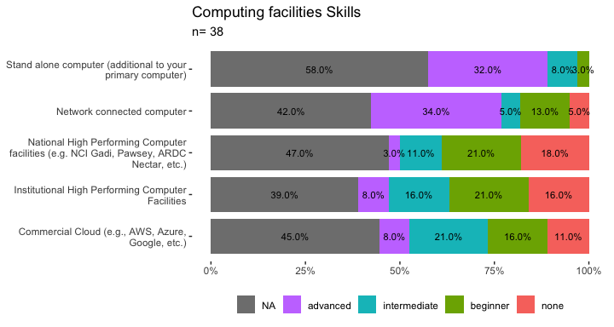

Computer facilities Skills (no missing)
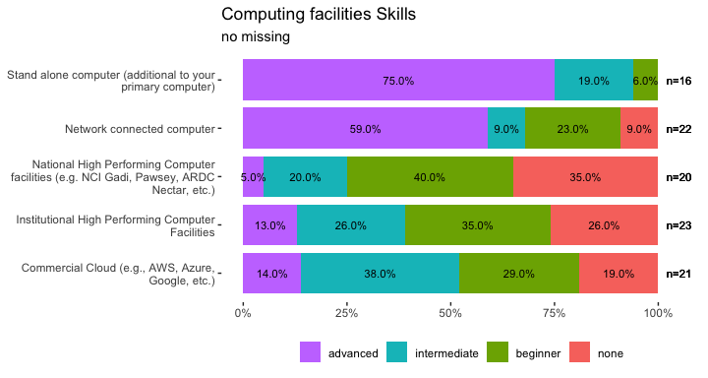

Programming Languages, IDEs and Data Science Platforms Skills
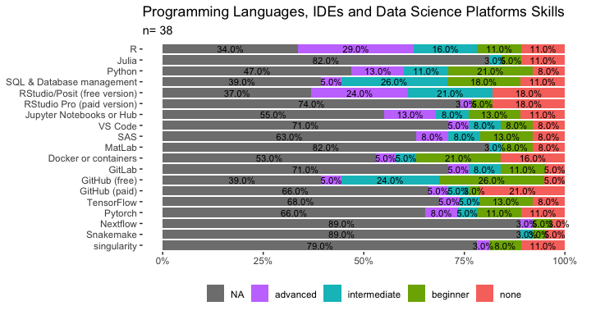

Programming Languages, IDEs and Data Science Platforms Skills (no missing)
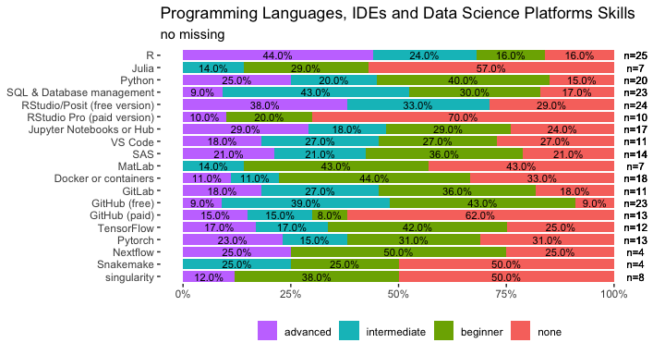

Advanced Analytics AI and non-Ai Skills
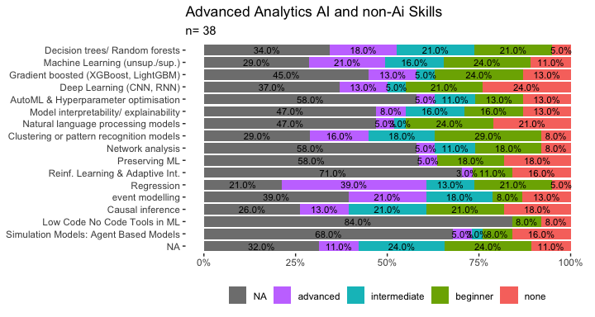

Advanced Analytics AI and non-Ai Skills (no missing)
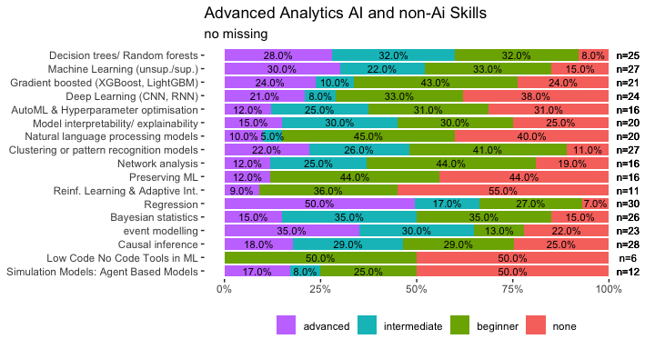

Domain Specific Analytic Skills
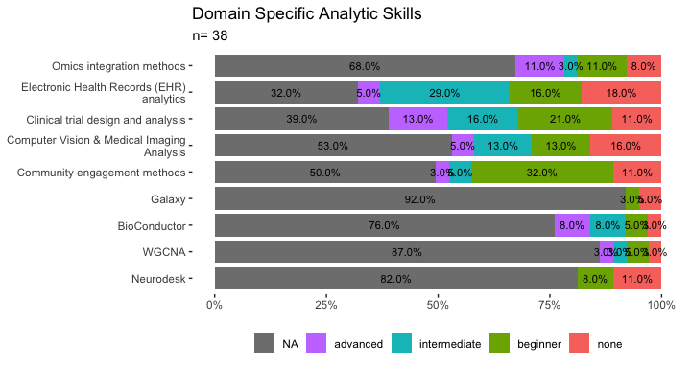

Domain Specific Analytic Skills (no missing)
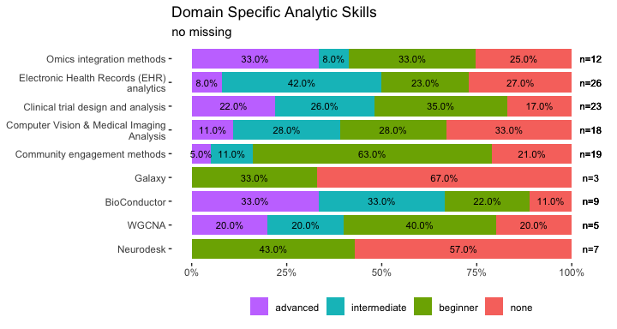

Gen-Ai and LLM Skills
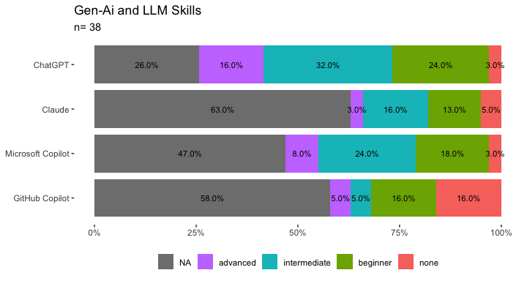

Gen-Ai and LLM Skills (no missing)
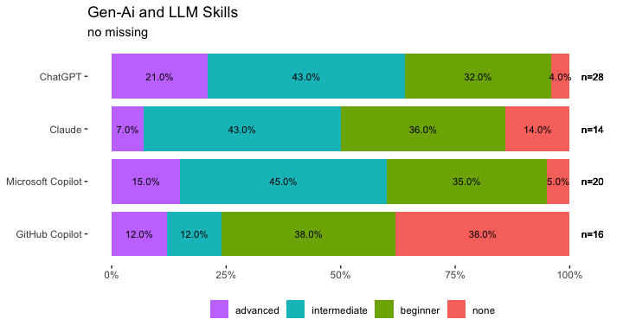

Demand, importance and impact
Table shows the demand, importance and impact for the different computing facilities, programs and tools, Advanced analytics, Domain specific analytics, GenAi and LLMs asked about in the survey.
NOTE ChatGPT and Claude were asked as free and Paid for usage, regarding skills only as Claude and ChatGPT, hence used the skills percentages for both paid and free versions. Excel, Federated learning models or distributed AI frameworks, Graph neural networks and knowledge graphs, Pilot, Power BI, Sandbox instances of LLMs, and Survival analysis/ time to event modelling, did NOT get any answers in skills part of the survey, hence impact could not be calculated with proposal a.

Checking some adaptations of scores
As per discussion with Dyvia and Nicola, I will look at the impact score as additive rather than multiplicative. As defined right now, Impact is bounded to be between 0 and 2 as demand itself is the sum of the percentages of 2 levels of a variable, hence Demand is between 0 and 1, and then Preparedness for use is built as a weighted combination of percentages of 3 levels of skill; the highest weight is 2 and hence the maximum the Preparedness for use score can be is 2 (if 100% of respondents said Advanced). Hence multiplying Demand and Preparedness is bounded by 2.
Creating then $Impact_{add}$ as the additive impact will be between 0 and 3 and defined by:
$$Impact_{add}=\text{Demand}+\text{Preparedness index}$$
the tools get ranked both ways.
Table shows the tools with the scores as asked in survey.
variable | demand | importance | impact | impact_add
Computing facilities
Stand alone computer (additional to your primary computer) | 0.62 | 1.77 | 1.07 | 2.340
Network connected computer | 0.81 | 5.79 | 1.12 | 2.195
National High Performing Computer facilities (e.g. NCI Gadi, Pawsey, ARDC Nectar, etc.) | 0.73 | 3.32 | 0.36 | 1.230
Institutional High Performing Computer Facilities | 0.82 | 5.12 | 0.57 | 1.515
Commercial Cloud (e.g., AWS, Azure, Google, etc.) | 0.76 | 4.00 | 0.61 | 1.565
Programs, IDEs and DS Platforms
R | 0.79 | 4.16 | 0.95 | 1.990
Python | 0.72 | 2.77 | 0.65 | 1.620
Julia | 0.23 | 0.55 | 0.07 | 0.515
SQL & Database management | 0.75 | 3.95 | 0.57 | 1.510
RStudio/Posit (free version) | 0.76 | 4.47 | 0.83 | 1.850
Jupyter Notebooks or Hub | 0.61 | 2.26 | 0.55 | 1.515
VS Code | 0.43 | 1.30 | 0.33 | 1.195
SAS | 0.48 | 1.00 | 0.39 | 1.290
MatLab | 0.32 | 0.53 | 0.11 | 0.675
RStudio Pro (paid version) | 0.35 | 0.60 | 0.11 | 0.650
Power BI | 0.54 | 1.64
Tableau | 0.30 | 0.55
Excel | 0.88 | 7.33
Docker or containers | 0.62 | 3.26 | 0.34 | 1.170
GitLab | 0.46 | 2.00 | 0.37 | 1.270
GitHub (free) | 0.76 | 7.60 | 0.60 | 1.545
GitHub (paid) | 0.46 | 1.24 | 0.23 | 0.950
TensorFlow | 0.41 | 1.71 | 0.30 | 1.130
Pytorch | 0.43 | 1.79 | 0.33 | 1.195
Nextflow | 0.22 | 0.81 | 0.16 | 0.970
Snakemake | 0.17 | 0.59 | 0.06 | 0.545
singularity | 0.31 | 1.82 | 0.13 | 0.740
Advanced analytics (AI and non-AI)
Regression | 0.97 | 48.50 | 1.27 | 2.275
Causal inference | 0.83 | 6.92 | 0.66 | 1.625
Survival analysis/ time to event modelling | 0.73 | 3.65
Bayesian statistics | 0.81 | 8.10 | 0.67 | 1.635
Decision trees/ Random forests | 0.83 | 6.92 | 0.86 | 1.870
Machine Learning (unsupervised/supervised) | 0.91 | 45.50 | 0.90 | 1.895
Gradient boosted (XGBoost, LightGBM) | 0.64 | 9.14 | 0.51 | 1.435
Deep Learning (CNN, RNN) | 0.71 | 10.14 | 0.47 | 1.375
AutoML & Hyperparameter optimisation | 0.52 | 5.20 | 0.34 | 1.165
Model interpretability/ explainability | 0.61 | 6.10 | 0.46 | 1.360
Clustering or pattern recognition models | 0.78 | 15.60 | 0.71 | 1.685
Federated learning models or distributed AI frameworks | 0.57 | 4.75
Graph neural networks and knowledge graphs | 0.52 | 4.33
Network analysis | 0.49 | 2.88 | 0.35 | 1.200
Preserving ML | 0.51 | 3.00 | 0.23 | 0.970
Reinforcement Learning & Adaptive Interventions | 0.37 | 2.18 | 0.13 | 0.730
Domain specific analytics
Omics integration methods | 0.37 | 1.23 | 0.33 | 1.275
Electronic Health Records (EHR) analytics | 0.73 | 4.87 | 0.51 | 1.425
Clinical trial design and analysis | 0.68 | 3.40 | 0.60 | 1.555
Computer Vision & Medical Imaging Analysis | 0.61 | 2.26 | 0.39 | 1.250
Community engagement methods | 0.56 | 1.93 | 0.29 | 1.085
Galaxy | 0.14 | 0.38 | 0.02 | 0.305
BioConductor | 0.32 | 1.33 | 0.35 | 1.420
WGCNA | 0.17 | 0.68 | 0.14 | 0.970
Neurodesk | 0.22 | 1.47 | 0.05 | 0.435
GenAi and LLMs
Claude (paid) | 0.44 | 1.29 | 0.33 | 1.190
Claude (free) | 0.37 | 0.90 | 0.28 | 1.120
ChatGPT (paid) | 0.66 | 2.28 | 0.67 | 1.670
ChatGPT (free) | 0.73 | 2.70 | 0.74 | 1.740
Sandbox instances of LLMs | 0.51 | 2.55
Microsoft Copilot | 0.63 | 2.17 | 0.58 | 1.555
pilot | 0.49 | 1.44
Table : Demand, importance and impact scores
Tables , , , and show the tables for each group separately and ordered in descending order by demand, then by importance and then impact for Computing facilities, Programs, IDEs and DS Platforms, Advanced analytics (AI and non-AI), Domain specific analytics and GenAi and LLMs

Computing Facilities
Computing facilities | demand | importance | impact | impact_add
Institutional High Performing Computer Facilities | 0.82 | 5.12 | 0.57 | 1.52
Network connected computer | 0.81 | 5.79 | 1.12 | 2.20
Commercial Cloud (e.g., AWS, Azure, Google, etc.) | 0.76 | 4.00 | 0.61 | 1.56
National High Performing Computer facilities (e.g. NCI Gadi, Pawsey, ARDC Nectar, etc.) | 0.73 | 3.32 | 0.36 | 1.23
Stand alone computer (additional to your primary computer) | 0.62 | 1.77 | 1.07 | 2.34
n: 5
Table : Demand, importance and impact scores for Computing facilities

Programs, IDEs and DS platforms
Programs, IDES and DS Platforms | demand | importance | impact | impact_add
Excel | 0.88 | 7.33
R | 0.79 | 4.16 | 0.95 | 1.99
GitHub (free) | 0.76 | 7.60 | 0.60 | 1.54
RStudio/Posit (free version) | 0.76 | 4.47 | 0.83 | 1.85
SQL & Database management | 0.75 | 3.95 | 0.57 | 1.51
Python | 0.72 | 2.77 | 0.65 | 1.62
Docker or containers | 0.62 | 3.26 | 0.34 | 1.17
Jupyter Notebooks or Hub | 0.61 | 2.26 | 0.55 | 1.51
Power BI | 0.54 | 1.64
SAS | 0.48 | 1.00 | 0.39 | 1.29
GitLab | 0.46 | 2.00 | 0.37 | 1.27
GitHub (paid) | 0.46 | 1.24 | 0.23 | 0.95
VS Code | 0.43 | 1.30 | 0.33 | 1.20
Pytorch | 0.43 | 1.79 | 0.33 | 1.20
TensorFlow | 0.41 | 1.71 | 0.30 | 1.13
RStudio Pro (paid version) | 0.35 | 0.60 | 0.11 | 0.65
MatLab | 0.32 | 0.53 | 0.11 | 0.68
singularity | 0.31 | 1.82 | 0.13 | 0.74
Tableau | 0.30 | 0.55
Julia | 0.23 | 0.55 | 0.07 | 0.52
Nextflow | 0.22 | 0.81 | 0.16 | 0.97
Snakemake | 0.17 | 0.59 | 0.06 | 0.55
n: 22
Table : Demand, importance and impact scores for Programs, IDEs and DS platforms

Advanced Analytics
Advanced analytics | demand | importance | impact | impact_add
Regression | 0.97 | 48.50 | 1.27 | 2.28
Machine Learning (unsupervised/supervised) | 0.91 | 45.50 | 0.90 | 1.90
Decision trees/ Random forests | 0.83 | 6.92 | 0.86 | 1.87
Causal inference | 0.83 | 6.92 | 0.66 | 1.62
Bayesian statistics | 0.81 | 8.10 | 0.67 | 1.63
Clustering or pattern recognition models | 0.78 | 15.60 | 0.71 | 1.69
Survival analysis/ time to event modelling | 0.73 | 3.65
Deep Learning (CNN, RNN) | 0.71 | 10.14 | 0.47 | 1.38
Gradient boosted (XGBoost, LightGBM) | 0.64 | 9.14 | 0.51 | 1.44
Model interpretability/ explainability | 0.61 | 6.10 | 0.46 | 1.36
Federated learning models or distributed AI frameworks | 0.57 | 4.75
AutoML & Hyperparameter optimisation | 0.52 | 5.20 | 0.34 | 1.17
Graph neural networks and knowledge graphs | 0.52 | 4.33
Preserving ML | 0.51 | 3.00 | 0.23 | 0.97
Network analysis | 0.49 | 2.88 | 0.35 | 1.20
Reinforcement Learning & Adaptive Interventions | 0.37 | 2.18 | 0.13 | 0.73
n: 16
Table : Demand, importance and impact scores for Advanced Analytics

Domain specific analytics
Domain Specific analytics | demand | importance | impact | impact_add
Electronic Health Records (EHR) analytics | 0.73 | 4.87 | 0.51 | 1.43
Clinical trial design and analysis | 0.68 | 3.40 | 0.60 | 1.55
Computer Vision & Medical Imaging Analysis | 0.61 | 2.26 | 0.39 | 1.25
Community engagement methods | 0.56 | 1.93 | 0.29 | 1.08
Omics integration methods | 0.37 | 1.23 | 0.33 | 1.27
BioConductor | 0.32 | 1.33 | 0.35 | 1.42
Neurodesk | 0.22 | 1.47 | 0.05 | 0.43
WGCNA | 0.17 | 0.68 | 0.14 | 0.97
Galaxy | 0.14 | 0.38 | 0.02 | 0.30
n: 9
Table : Demand, importance and impact scores for Domain specific analytics

GenAI and LLMs
GenAI and LLMs | demand | importance | impact | impact_add
ChatGPT (free) | 0.73 | 2.70 | 0.74 | 1.74
ChatGPT (paid) | 0.66 | 2.28 | 0.67 | 1.67
Microsoft Copilot | 0.63 | 2.17 | 0.58 | 1.56
Sandbox instances of LLMs | 0.51 | 2.55
pilot | 0.49 | 1.44
Claude (paid) | 0.44 | 1.29 | 0.33 | 1.19
Claude (free) | 0.37 | 0.90 | 0.28 | 1.12
n: 7
Table : Demand, importance and impact scores for GenAI and LLMs

